**WEEKLY TASK SOLUTION FOR AWS BOOTCAMP BY CLOUDSEC NETWORK**

**NAME: OLUFEMI AYOMITOPE**

# WEEK 1: Introduction to AWS Cloud

**\*Deliverable:**  
Provide evidence of an active account by submitting a screenshot of your AWS Management Console (e.g., showing your account ID or billing dashboard).

**STEP 1**: Logged in to AWS Management Console using my existing information

**STEP 2**: Clicked my account name at the top right and select **My Account**

**STEP 3: My Account ID displayed**

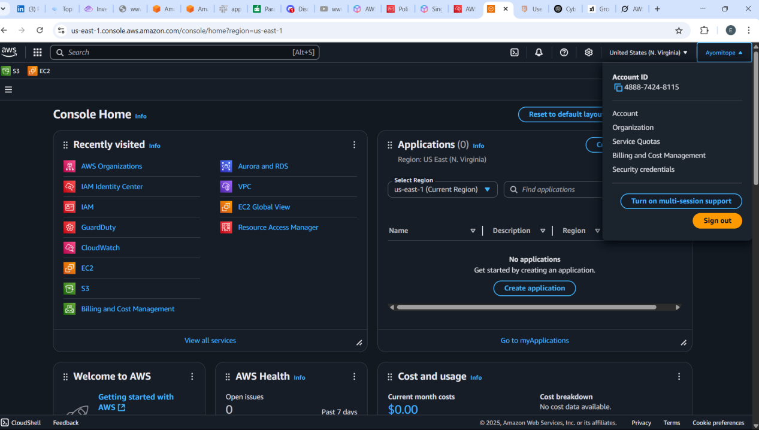

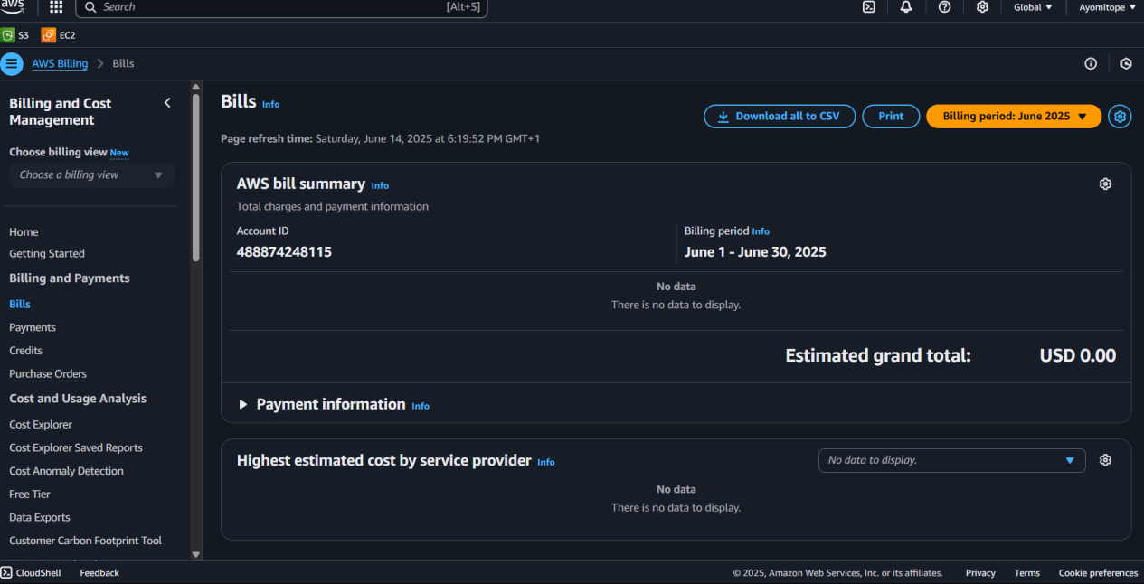

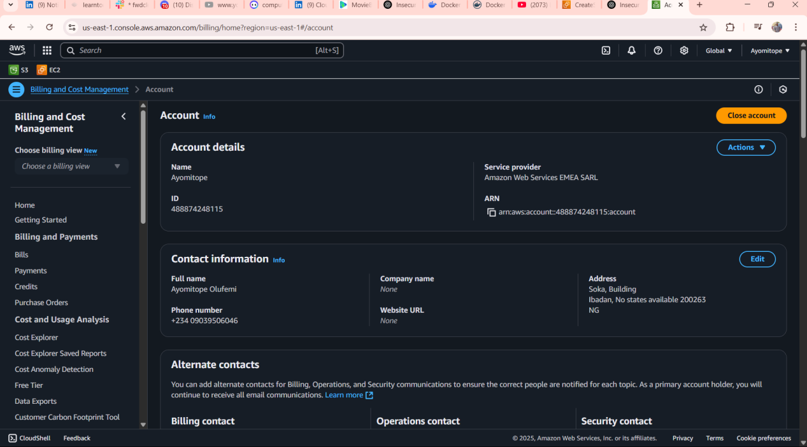

# WEEK 2: AWS Identity Center and Permission Sets

\***Deliverable:**  
Submit a screenshot showing the Identity Center instance, the user created, and the assigned permission set.

**STEP 1:** Sign in to AWS Management Console

**STEP 2:** Navigate to AWS Identity Center

**STEP 3:** Enable AWS Identity Center (if not already enabled)

**STEP 4:** Create a New User

**STEP 5:** Create a Permission Set Using “SecurityAudit” Policy

**STEP 6:** Assign the User to an AWS Account and Permission Set

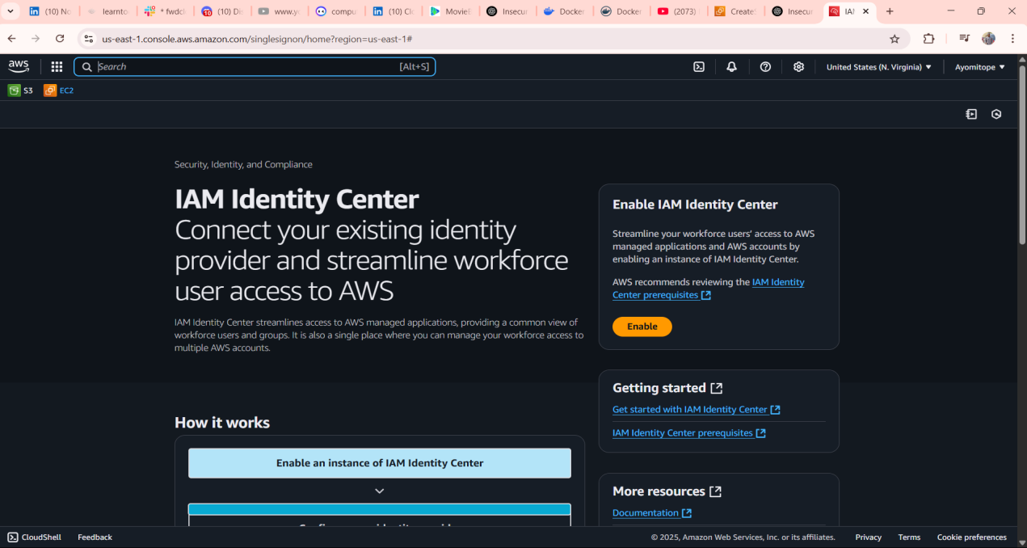

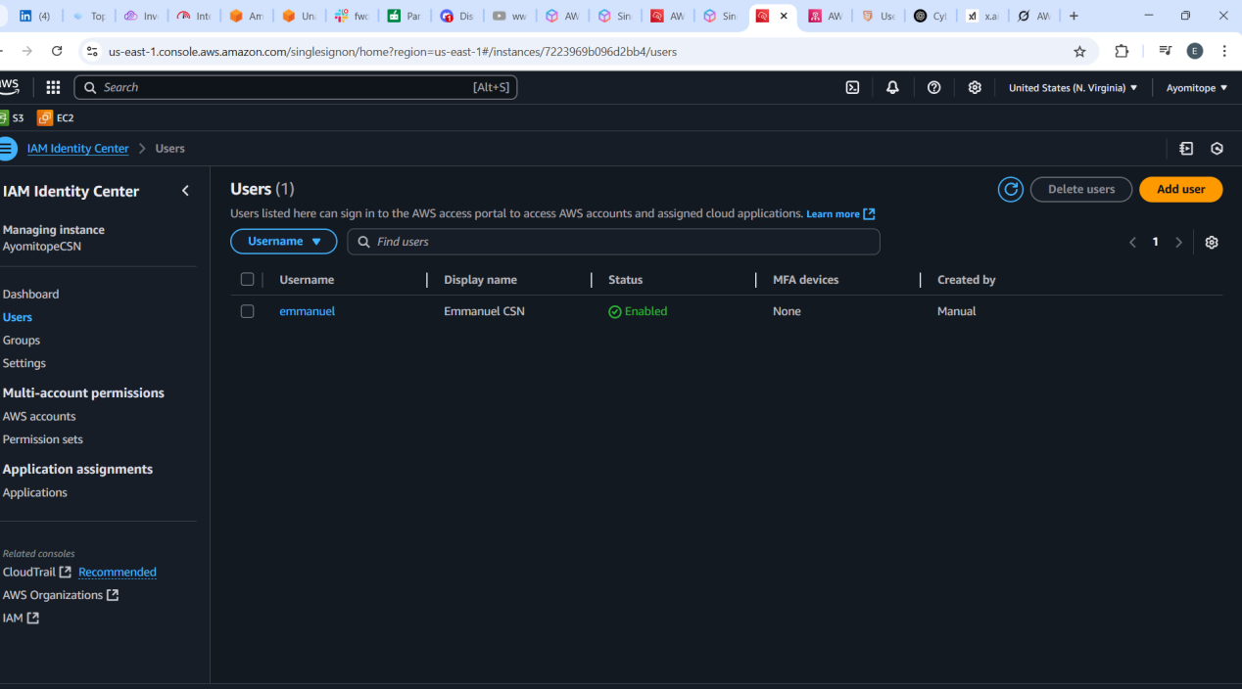

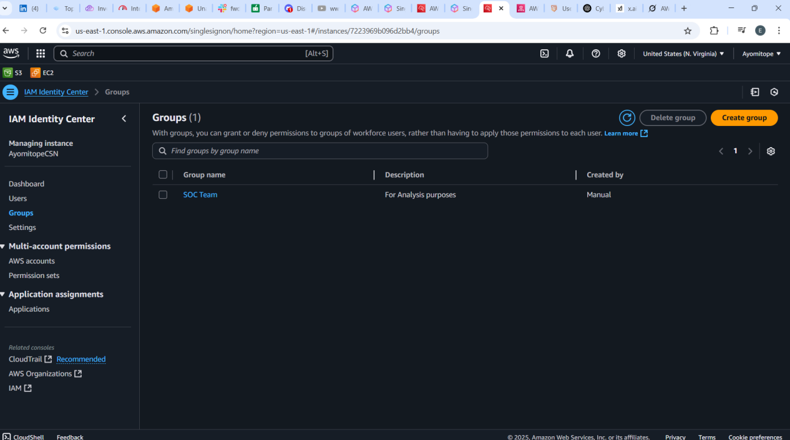

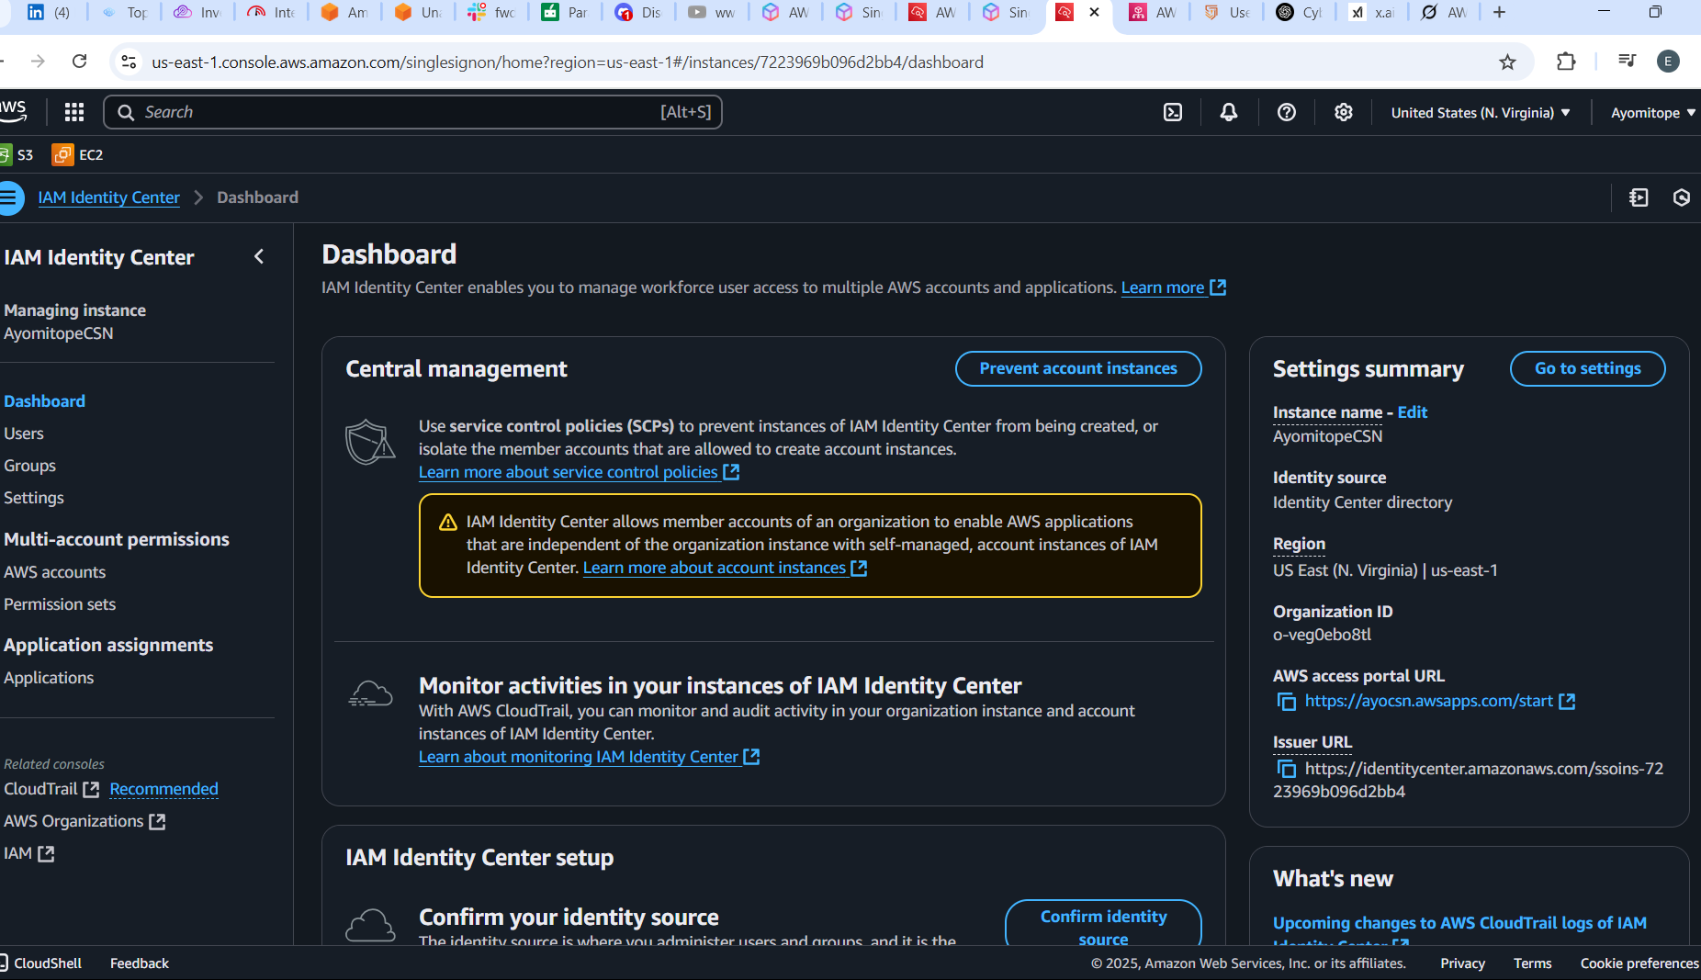

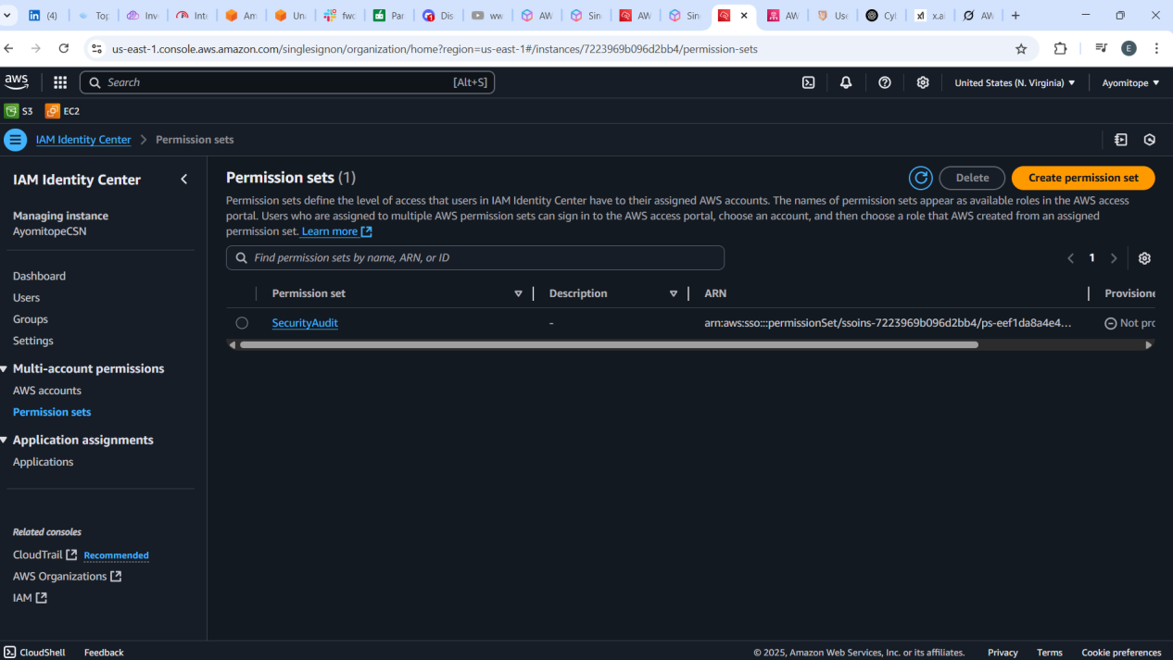

# WEEK 3: Provisioning and Securing EC2 Instances

**\*Deliverable**  
Provide screenshots of your running Windows EC2 instance in the AWS Management Console. The screenshots should clearly show:

* The instance’s Name tag set to CSN-Bootcamp-Week3,
* The Security Group inbound rules allowing RDP (port 3389) only from your public IP address,
* A successful Remote Desktop (RDP) connection to the instance.

**STEP 1:** Sign in to AWS Management Console

**STEP 2:** Navigate to EC2 Dashboard

**STEP 3:** Launch a New Instance  
· **Name** the instance: CSN-Bootcamp-Week3

· Chose **Amazon Windows Server 2022 Base AMI**

· Selected an instance type: t2.micro & created network settings

· Launched an Instance

**STEP 4:** When the Instance started running, it was connected via Remote Desktop (RDP)

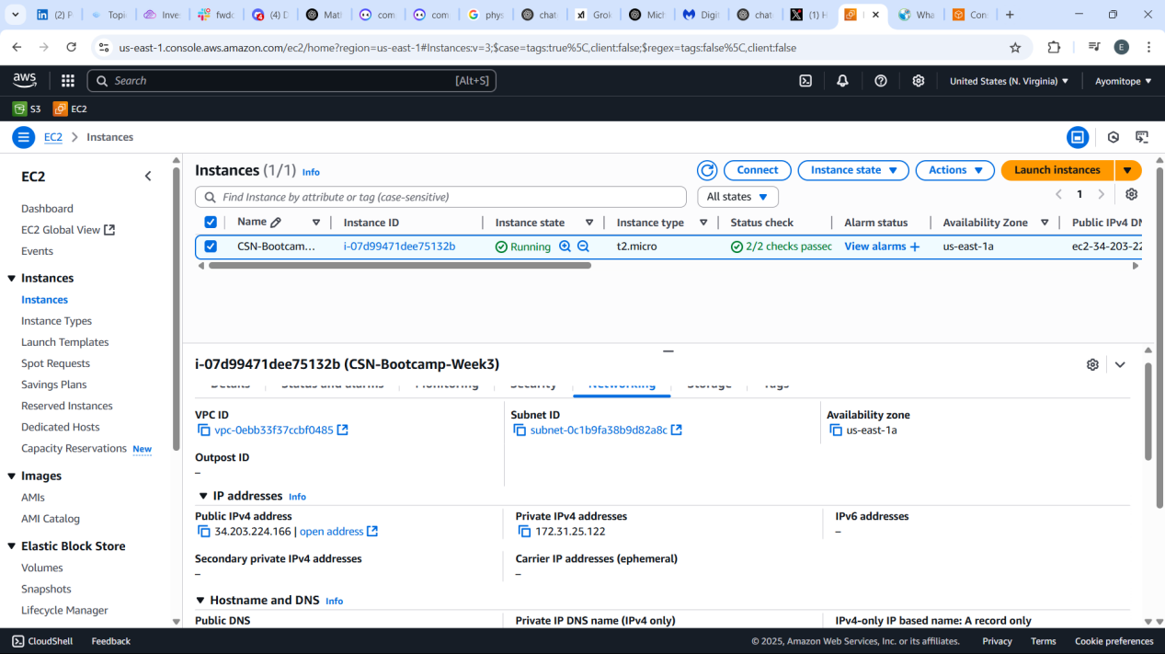

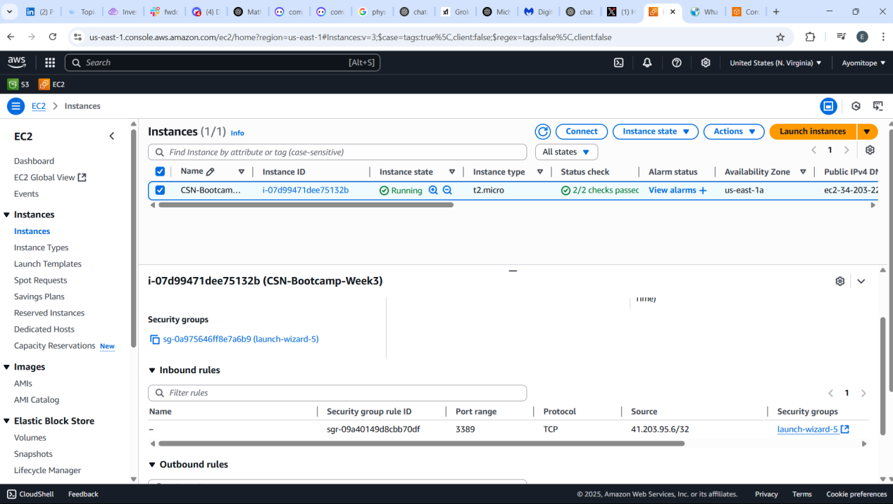

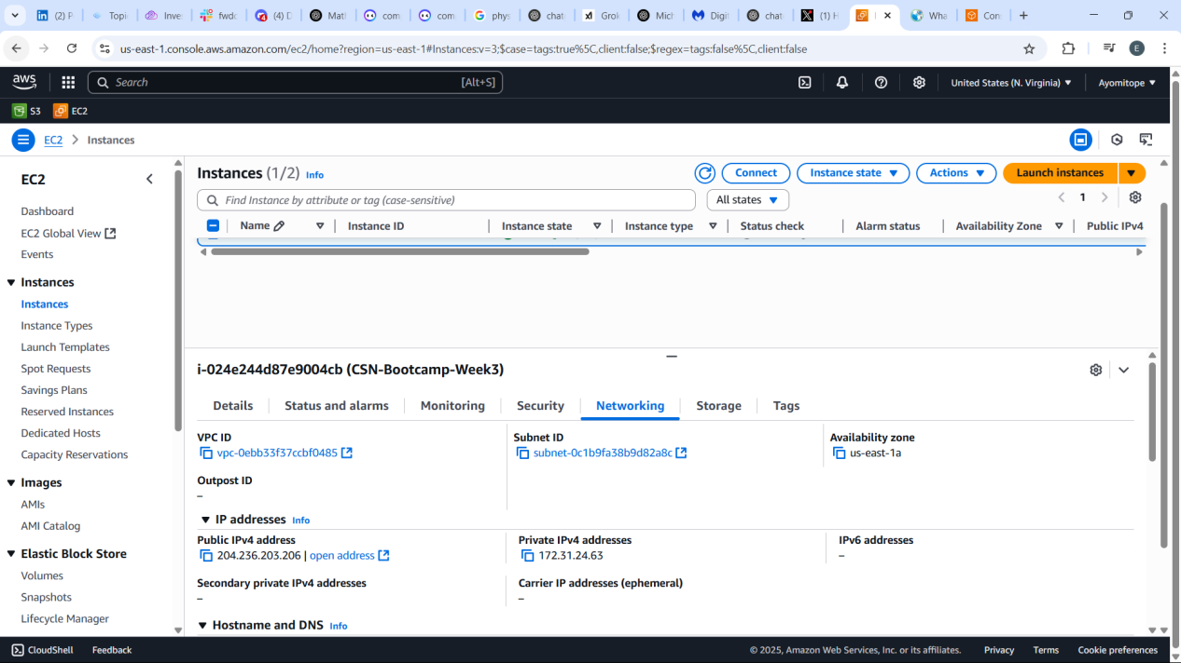

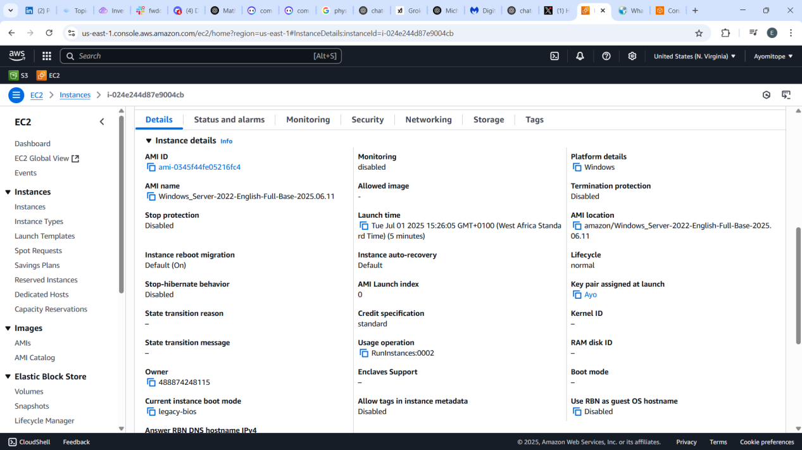

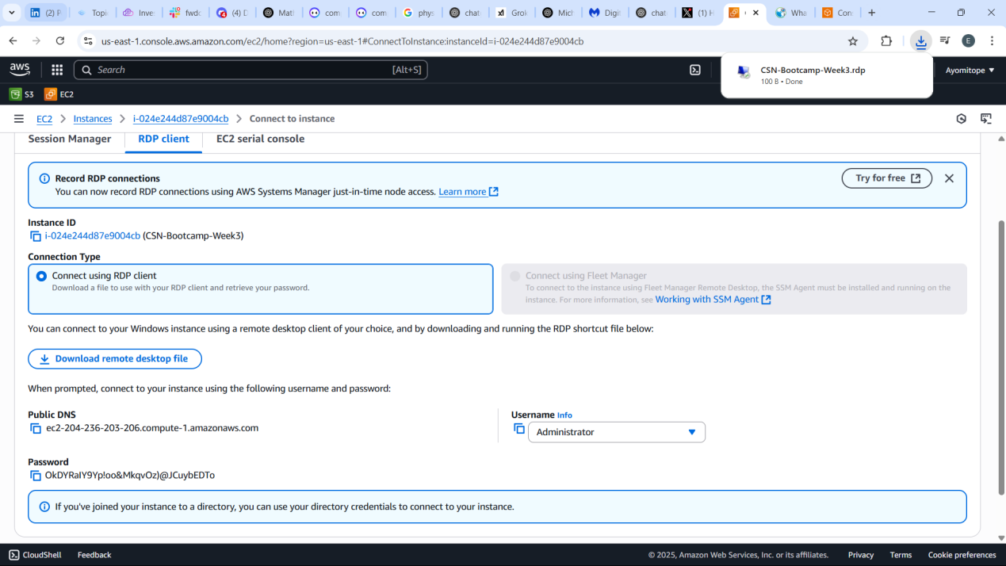

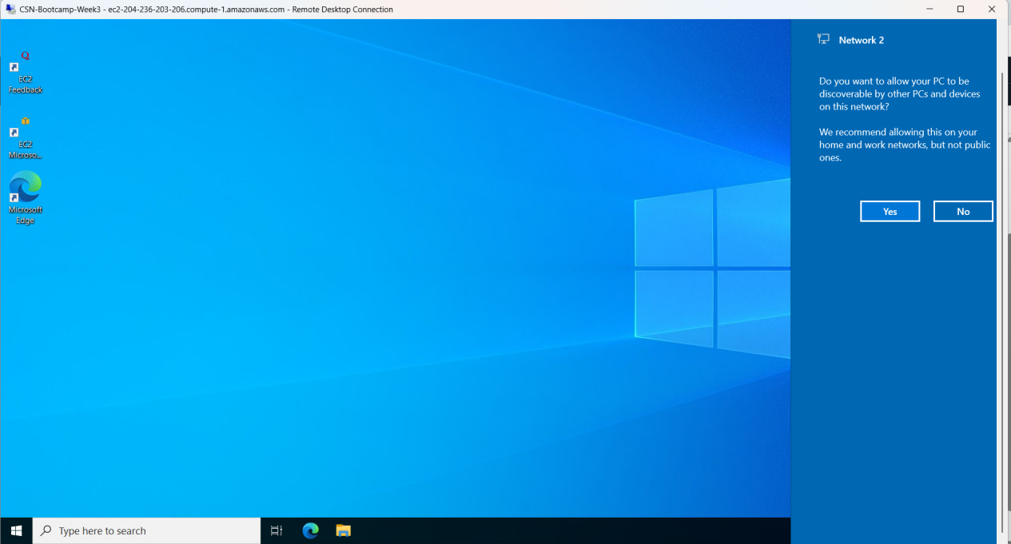

**WEEK 4: Cloud Networking with AWS VPC and Subnets**

**\*Deliverable**  
Provide clear screenshots from the AWS Console showing:

* The two VPCs and their CIDR blocks,
* The public and private subnets in each VPC,
* The VPC peering connection in **Active** status,
* The route tables with routes pointing to the other VPC's CIDR block through the peering connection

✅ STEP 1: Created two VPCs:  
✔️ VPC-A with CIDR block: [**10.10.0.0/16🔒**](http://10.10.0.0/16%F0%9F%94%92)   
✔️ VPC-B with CIDR block: [**10.20.0.0/16🔒**](http://10.20.0.0/16%F0%9F%94%92)  
  
✅ STEP 2: In each VPC, created:  
✔️1 Public Subnet (e.g., [**10.10.1.0/24**](http://10.10.1.0/24) in VPC-A)  
✔️1 Private Subnet (e.g., [**10.10.2.0/24**](http://10.10.2.0/24) in VPC-A)  
Repeat for VPC-B (e.g., [**10.20.1.0/24**](http://10.20.1.0/24), [**10.20.2.0/24**](http://10.20.2.0/24))  
  
✅ STEP 3: Set up a VPC Peering connection between VPC-A and VPC-B.  
✔️Requester: VPC-A  
✔️Accepter: VPC-B  
  
✅ STEP 4: Updated route tables in both VPCs so they can talk to each other via the peering connection.  
✔️In VPC-A, add a route to [**10.20.0.0/16**](http://10.20.0.0/16) via Peering Connection  
✔️In VPC-B, add a route to [**10.10.0.0/16**](http://10.10.0.0/16) via Peering Connection

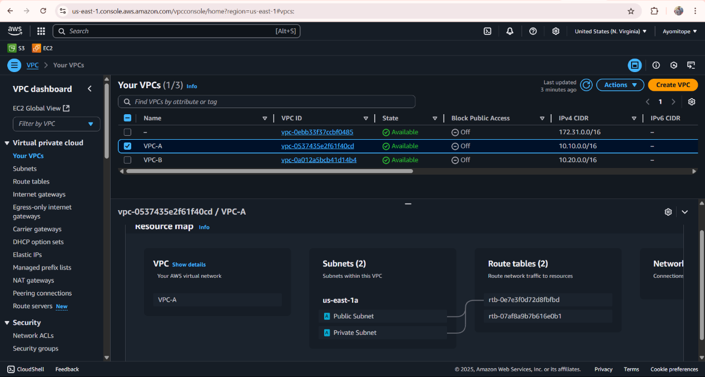

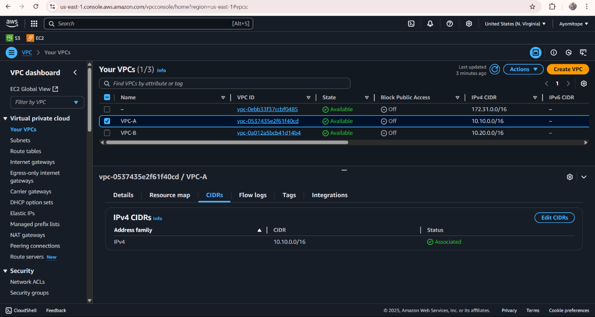

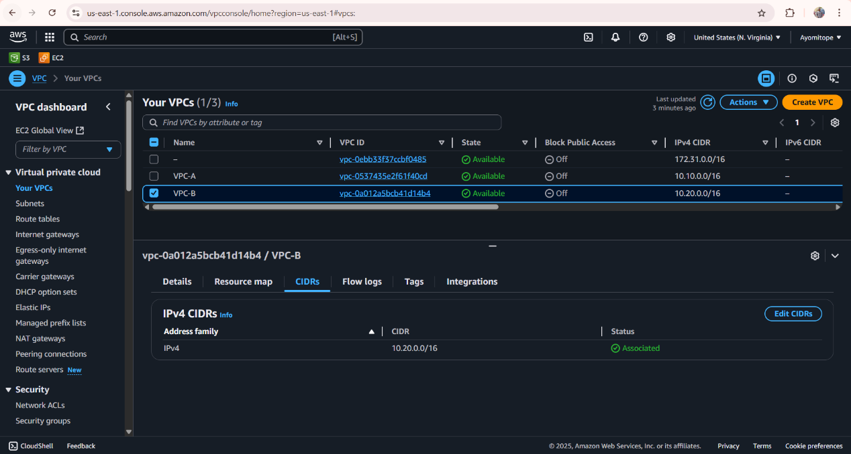

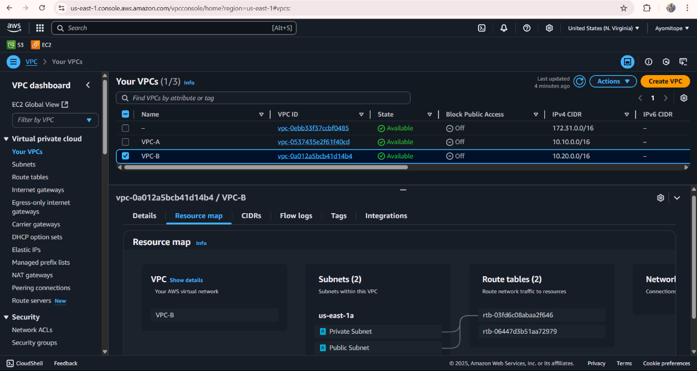

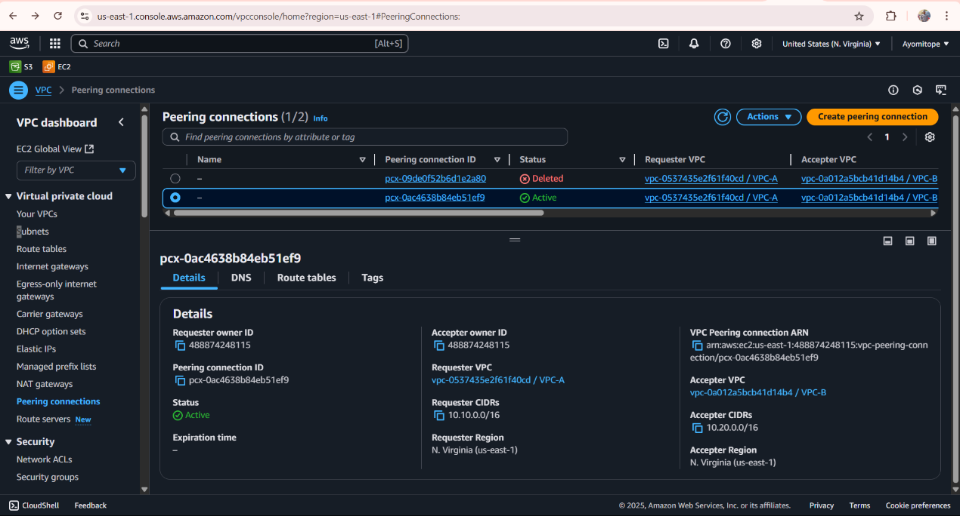

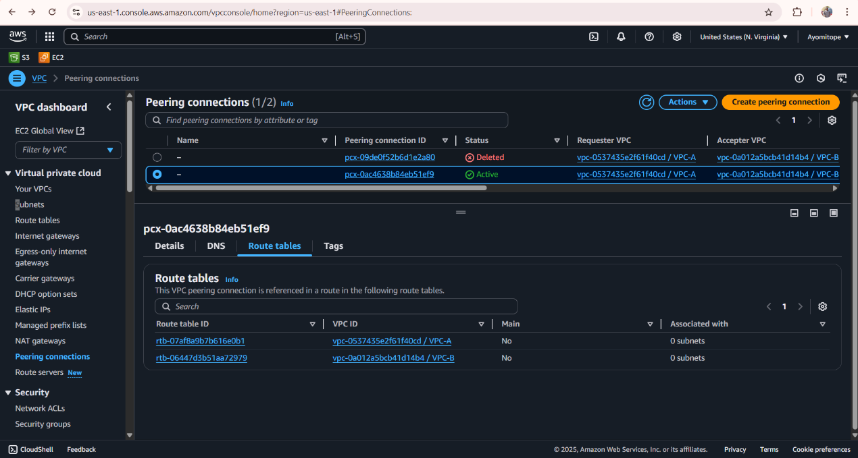

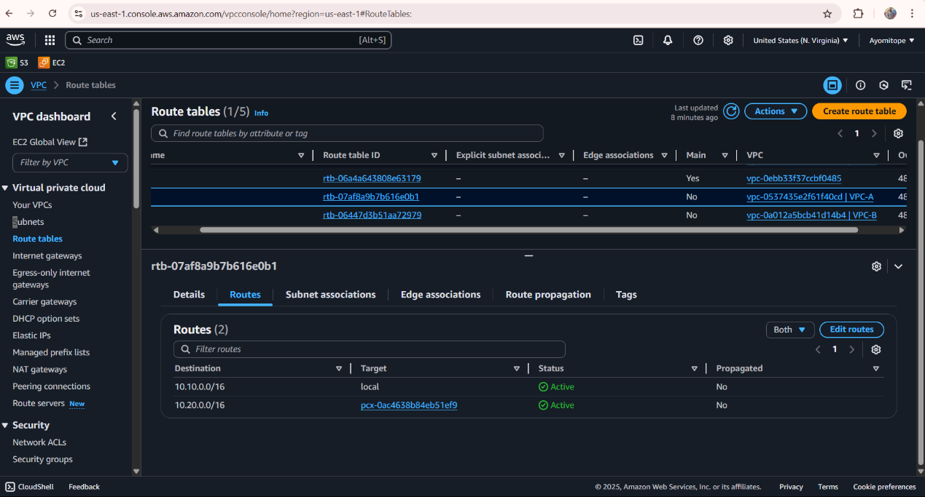

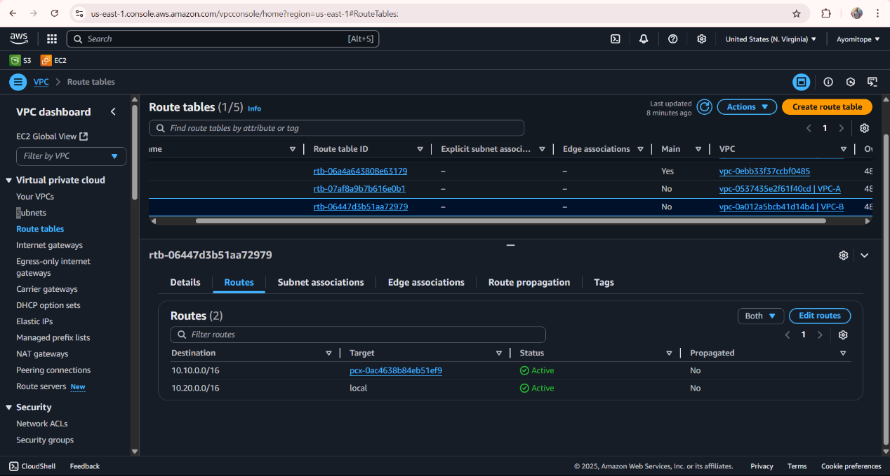

**WEEK 5**

Created a Security Group

1. In the AWS Console, go to **VPC > Security Groups**.
2. Clicked **Create security group**.
   * Name: grafana-sg
   * Description: “Allow inbound HTTP on port 3000”
   * VPC: my *VPC*
3. Under **Inbound rules**, added:
   * Type: **Custom TCP**
   * Port range: **3000**
   * Source: **0.0.0.0/0**

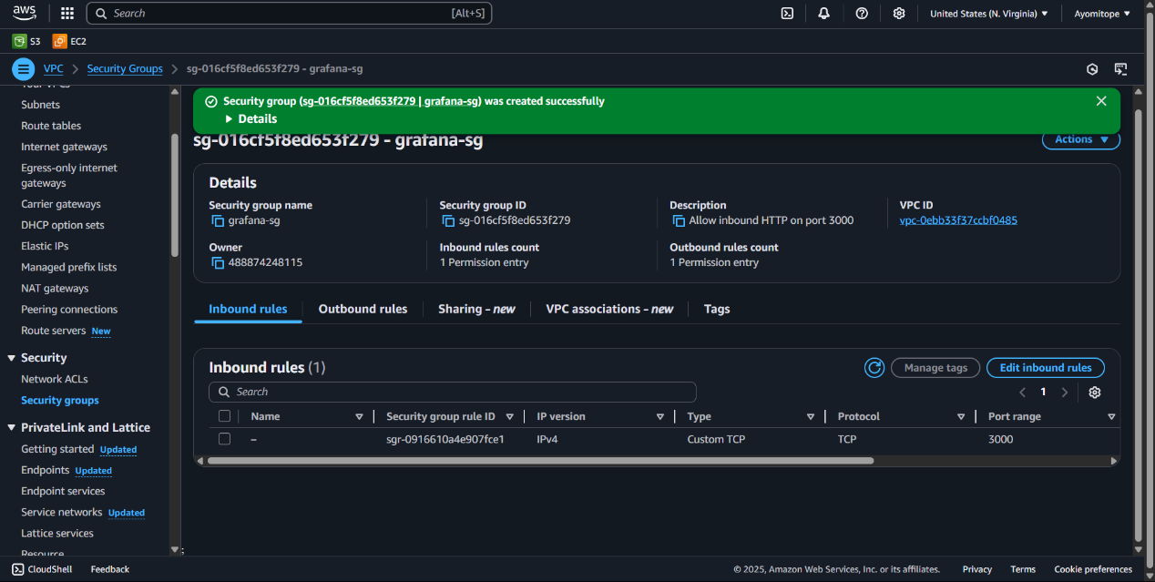

Set Up an ECS Cluster

1. In the Console, navigated to **ECS > Clusters**.
2. Click **Create cluster** > **Networking only (Powered by AWS Fargate)**.
3. Named it grafana-CL and click **Create**.

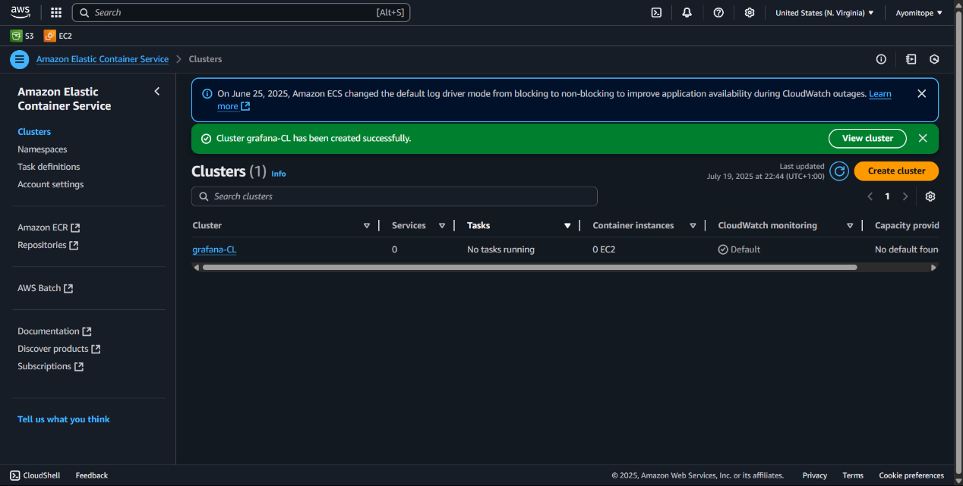

Define the Task Definition

1. Go to **ECS > Task Definitions** > **Create new Task Definition**.
2. Choose **FARGATE**, click **Next**.
3. Configure:
   * Task Definition Name: grafana-task
   * Task Role: *leave blank*
   * Network Mode: awsvpc
   * CPU & Memory: e.g., **0.5 vCPU** (512 MiB) / **1 GB**
4. Under **Container definitions**, click **Add container**:

* Name: grafana
* Image: grafana/grafana:latest
* Port mappings:
  + Container port: 3000
  + Protocol: tcp
* Click **Add** and then **Create** task definition

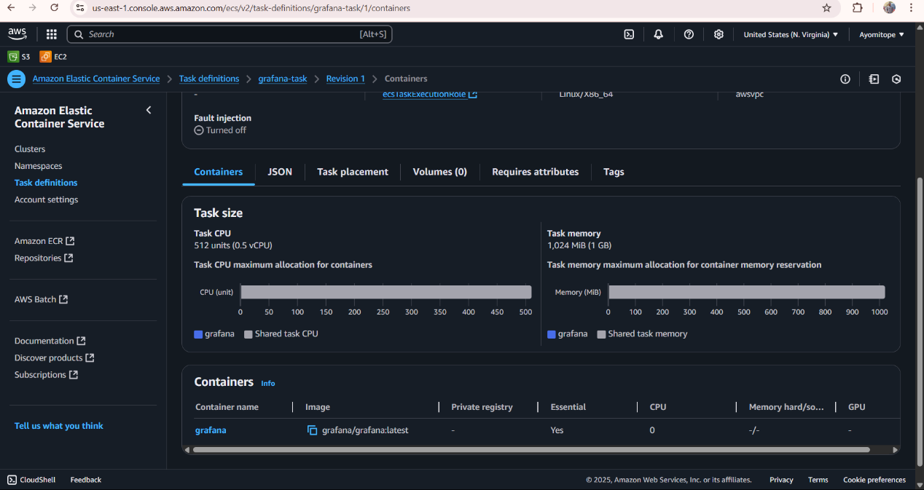

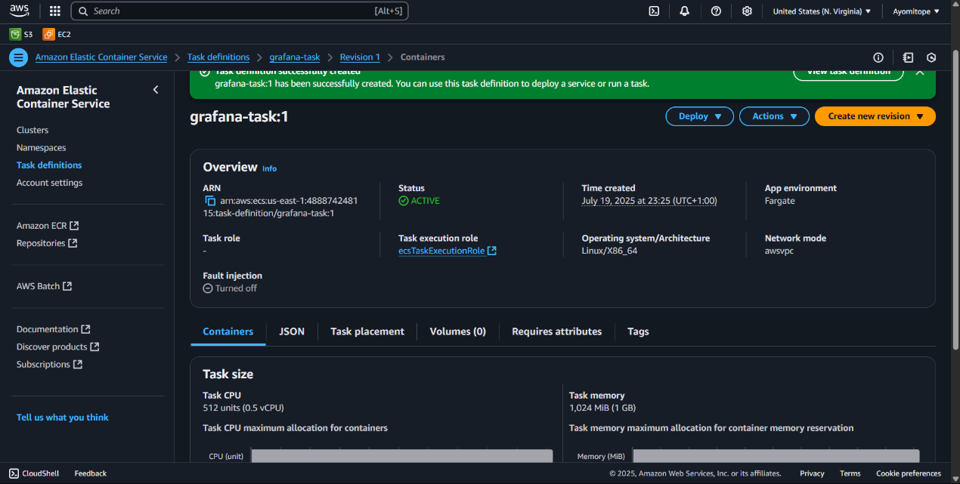

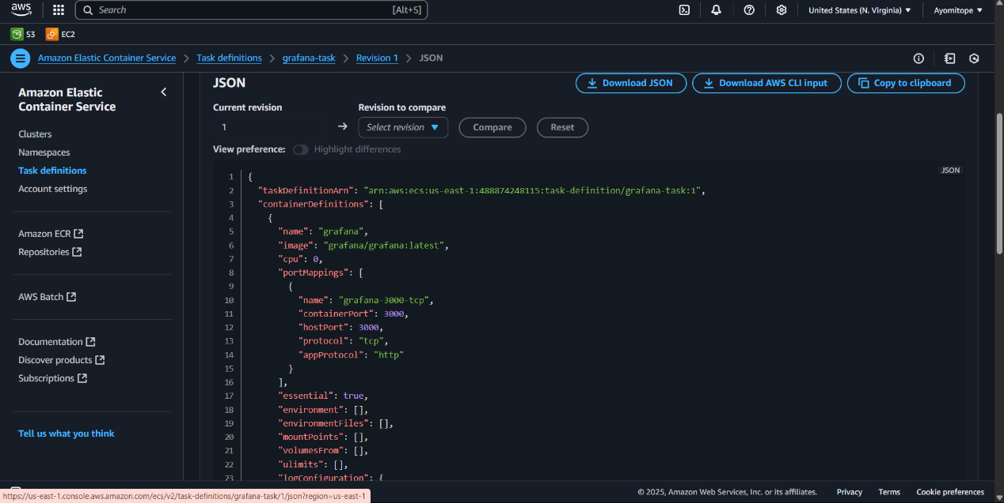

Run the Service

1. In your grafana-CL , click **Create** > **Create Service**.
2. Configure:
   * Launch type: **FARGATE**
   * Task Definition: grafana-task
   * Service name: grafana-service
   * Number of tasks: 1
3. Under **Networking**:
   * VPC: My *VPC*
   * Subnets: select a **public subnet**
   * Security groups: select grafana-sg
4. • Click **Next** through the defaults and **Create Service**.

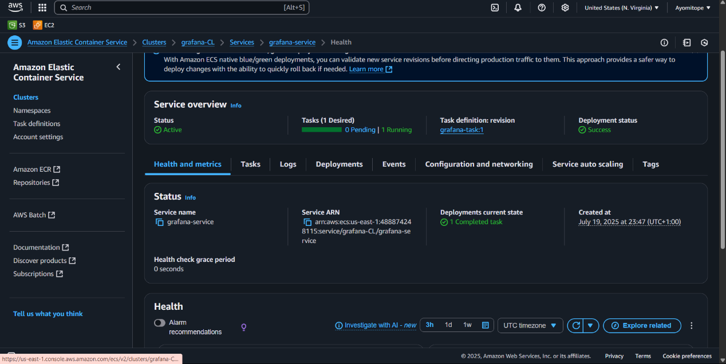

Access Grafana

1. In **EC2 > Network Interfaces**, find the ENI attached to my Grafana task.
2. Copy its **Public IPv4 address**.(54.221.12.105)
3. Open http:// 54.221.12.105:3000 in my browser.
4. Login with:

* Username: **admin**
* Password: **admin**

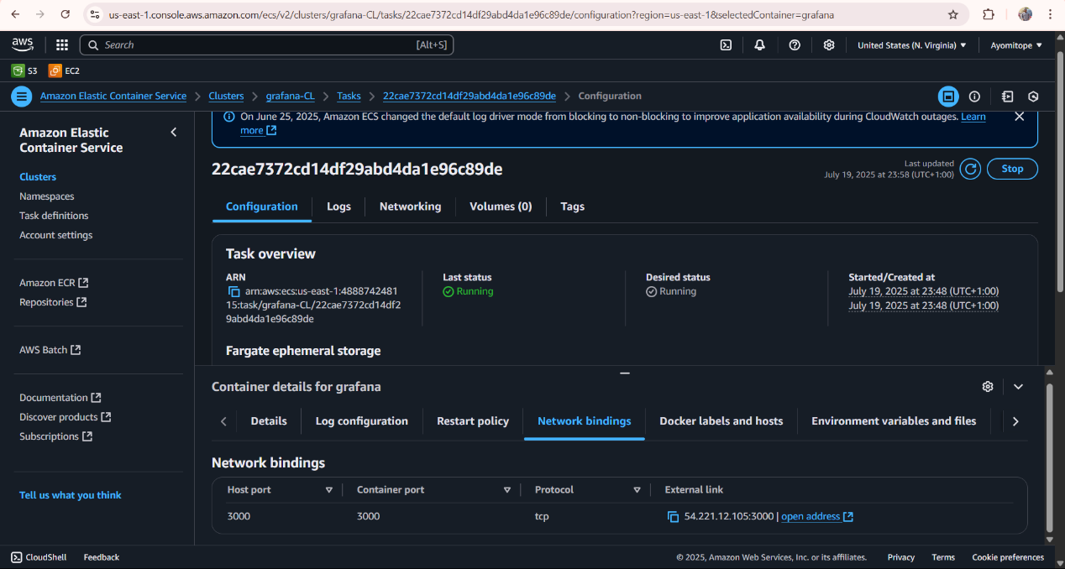

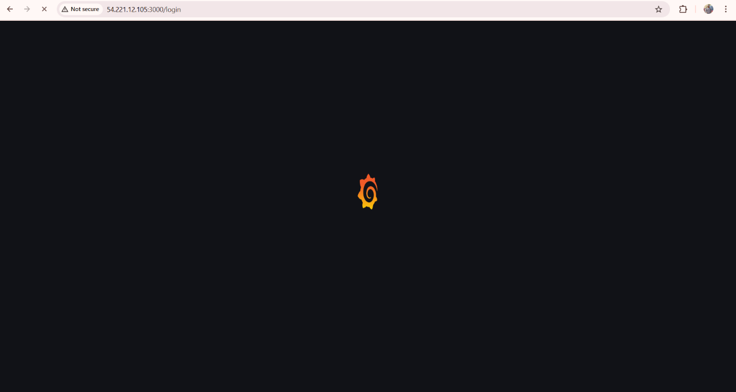

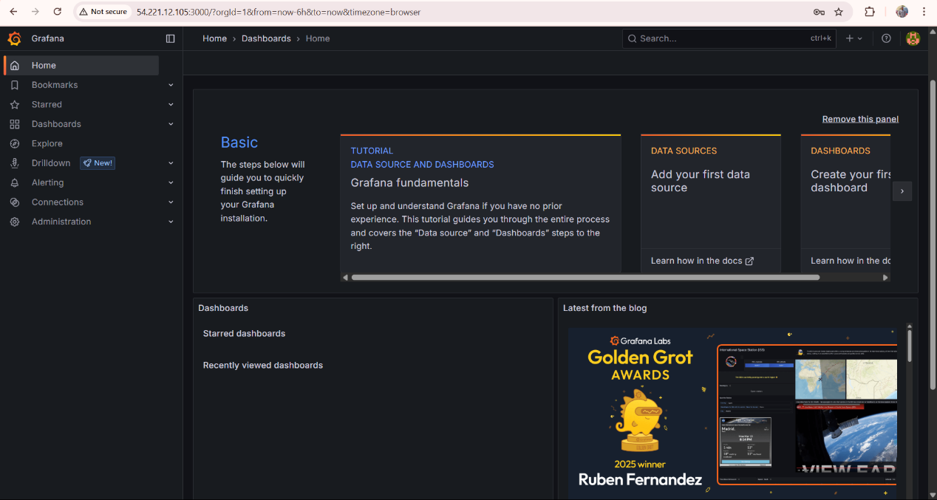

**WEEK 6**

**STEP 1**: Set Up the Database (PostgreSQL on RDS)

Go to: RDS > Databases > Create database

Choose:

Engine: PostgreSQL

Template: Free Tier (if eligible)

DB instance identifier: metabase-db

Username: metabase_user

Password: Choose and remember it

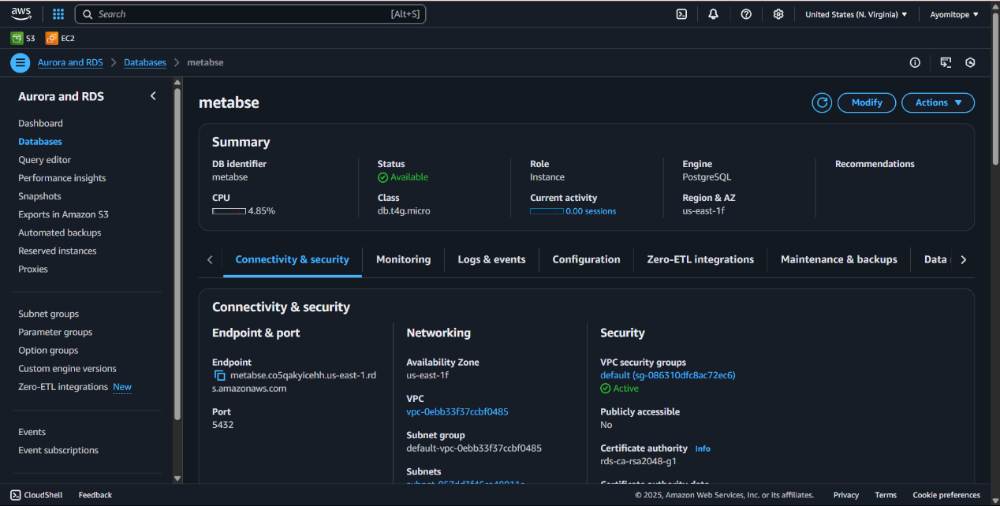

**STEP 2**: Create ECS Cluster

Go to: ECS > Clusters > Create Cluster

Choose: “Networking only (Fargate)”

Name it: metabase-cluster

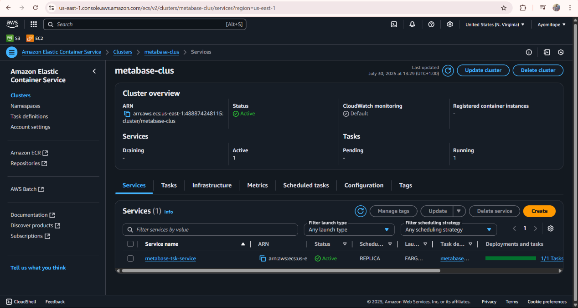

**STEP 3:** Create Security Groups

ECS Task SG

Name: ecs-task-sg

Inbound Rule: allow TCP 3000 from the Load Balancer SG

Load Balancer SG

Name: alb-sg

Inbound Rule: allow HTTP 80 from 0.0.0.0/0

RDS SG

Name: rds-sg

Inbound Rule: allow TCP 5432 from ECS Task SG

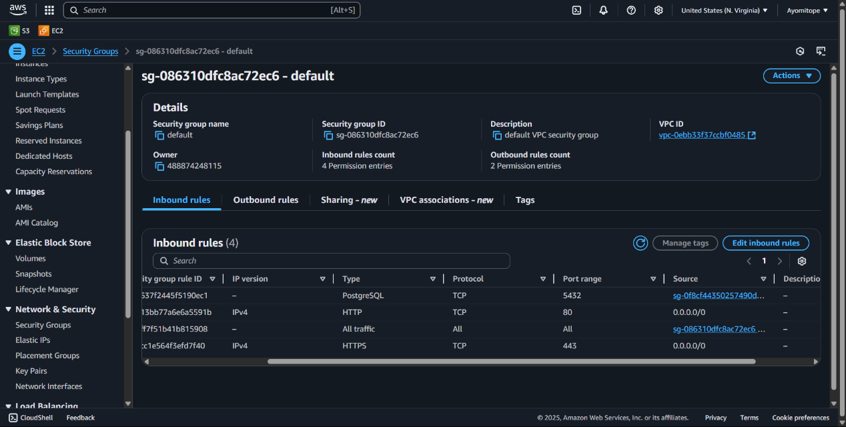

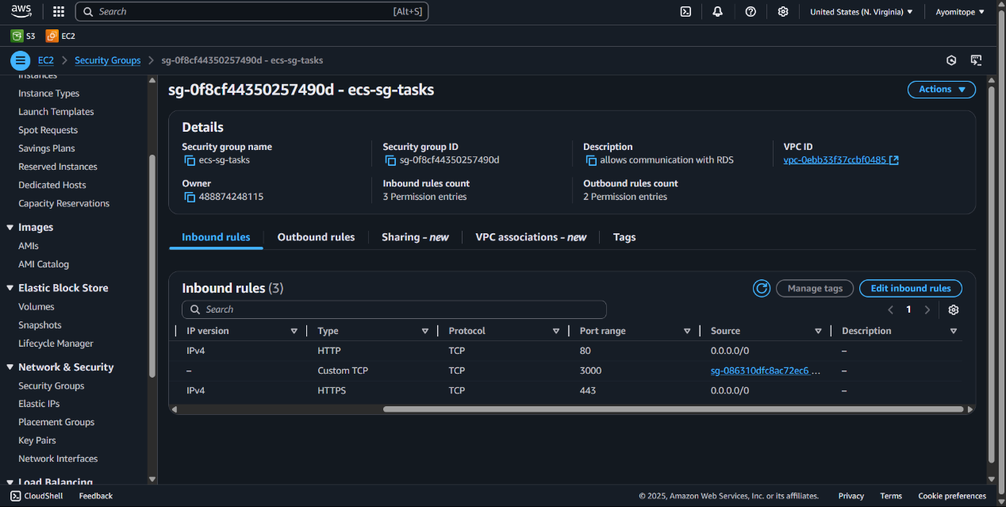

**STEP 4**: Create Target Group

Go to: EC2 > Target Groups > Create

Name: metabase-tg

Target type: IP

Protocol/Port: HTTP / 3000

Health check settings:

Protocol: HTTP

Path: /

Port: traffic port

Healthy threshold: 3

Unhealthy threshold: 5

Timeout: 10s

Interval: 30s

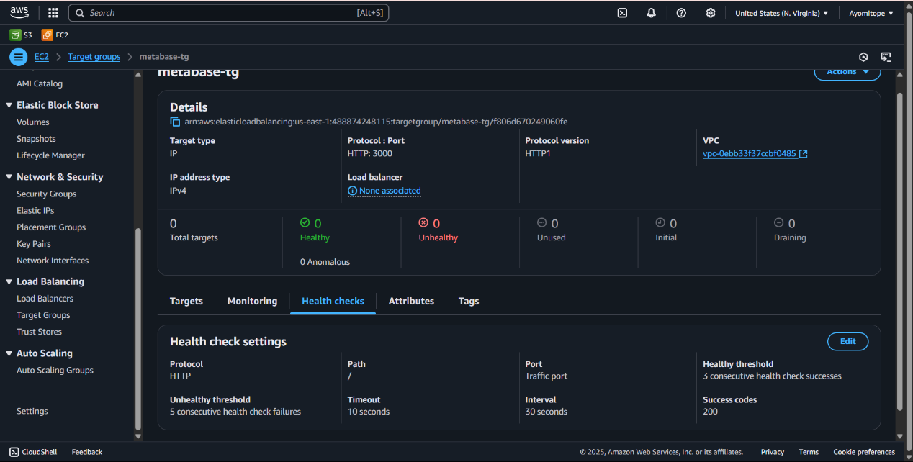

**STEP 5**: Create Load Balancer

Go to: EC2 > Load Balancers > Create Application Load Balancer

Name: metabase-lb

Scheme: internet-facing

Listeners: HTTP (port 80)

Select 2 public subnets

Security group: alb-sg

Forwarding rule:

Port 80 → Target group: metabase-tg

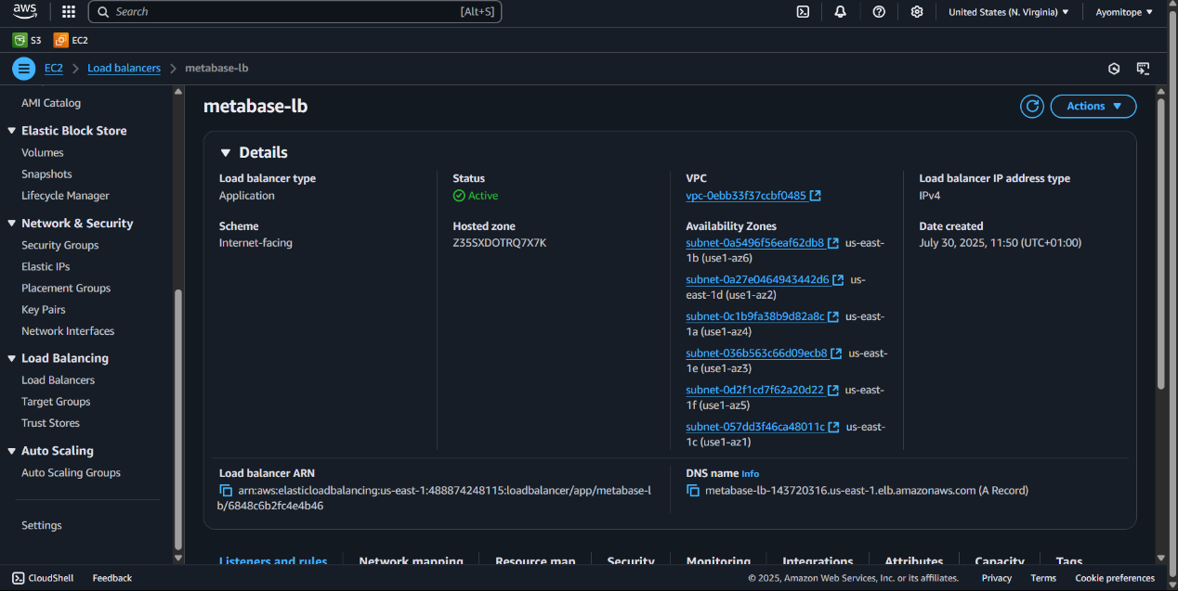

**STEP 6**: Create Task Definition (Fargate)

Go to ECS > Task Definitions > Create new task definition

Launch type: Fargate

Task name: metabase-tsk

CPU/Memory: 1 vCPU, 3 GB

Add container:

Name: metabase

Image: metabase/metabase:latest

Port mapping: 3000

Environment Variables:

MB_DB_TYPE=postgres

MB_DB_DBNAME=metabase

MB_DB_PORT=5432

MB_DB_USER=metabase_user

MB_DB_PASS=your_password

MB_DB_HOST=your-rds-endpoint.rds.amazonaws.com

"healthCheck": {

"command": ["CMD-SHELL", "curl -f http://localhost:3000 || exit 1"],

"interval": 30,

"timeout": 5,

"retries": 3,

"startPeriod": 60

}

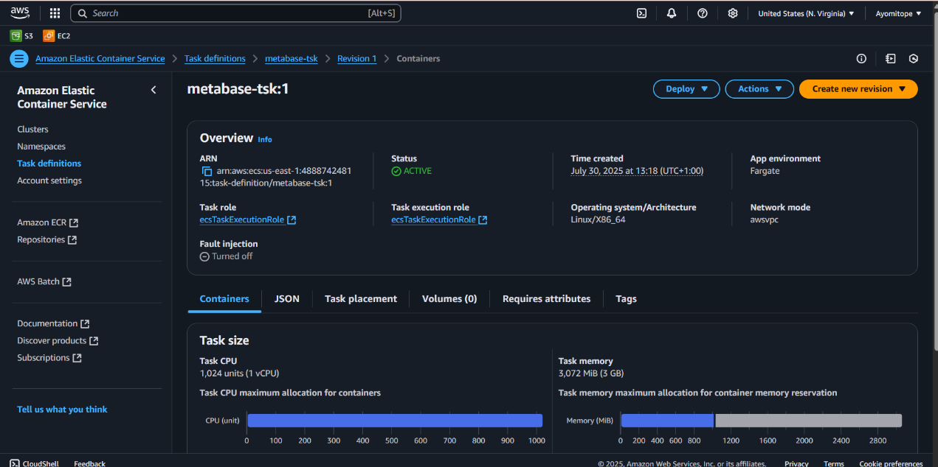

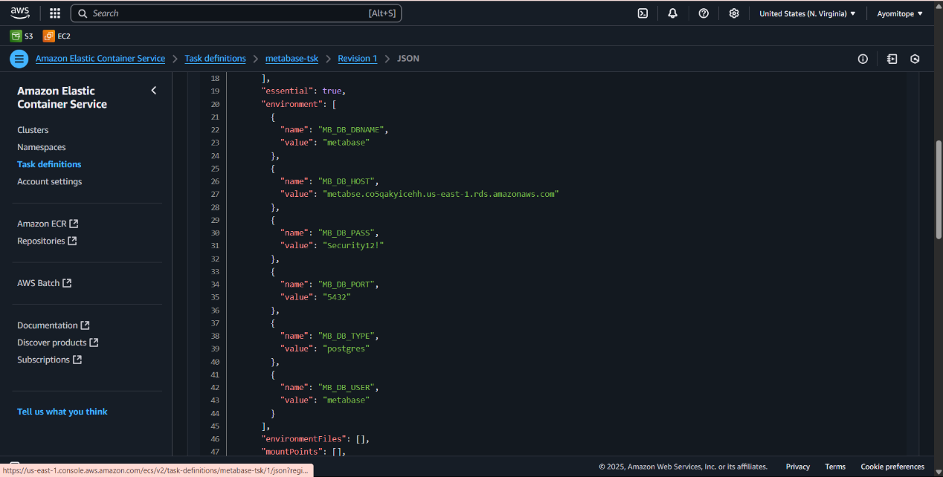

**STEP 7**: Create ECS Service

Go to ECS > Clusters > metabase-cluster > Create service

Launch type: Fargate

Task Definition: metabase-tsk

Service name: metabase-service

Number of tasks: 1

VPC: Same as your RDS and LB

Subnets: Select 2 public subnets

Security Group: ecs-task-sg

Enable Load Balancer integration:

Type: Application Load Balancer

Listener: HTTP 80

Target Group: metabase-tg

Click Deploy Service

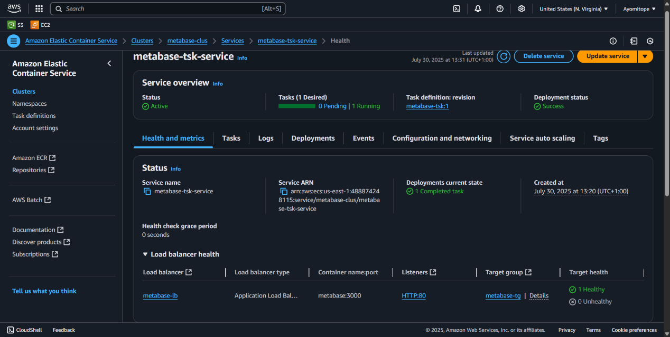

Go to the Load Balancer, copy the DNS name and paste it in a new tab

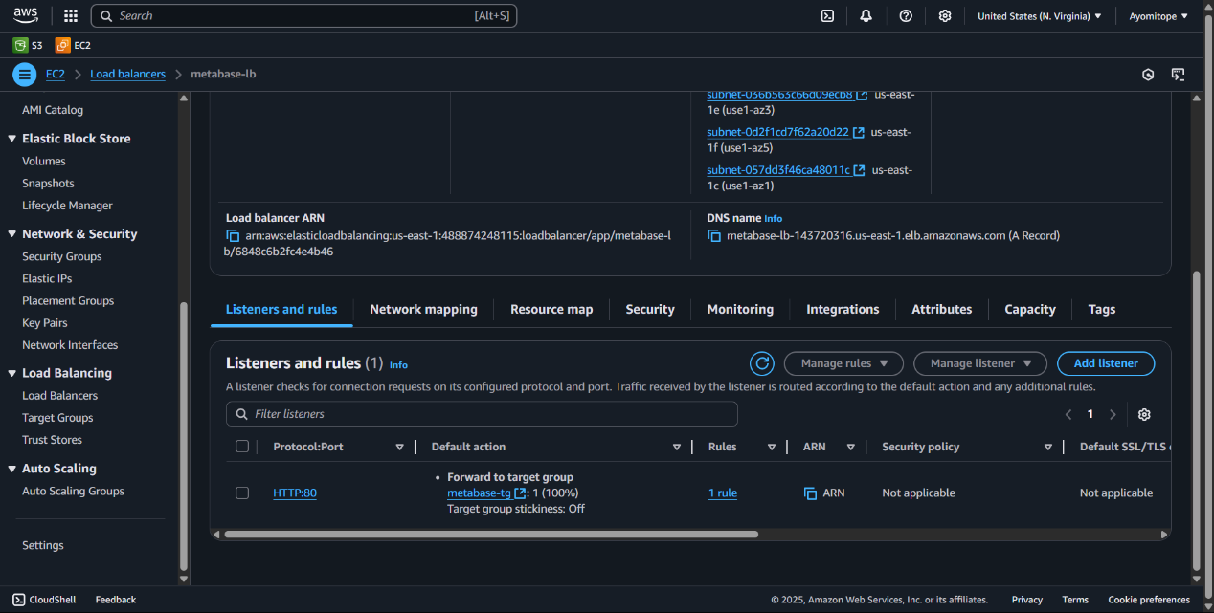

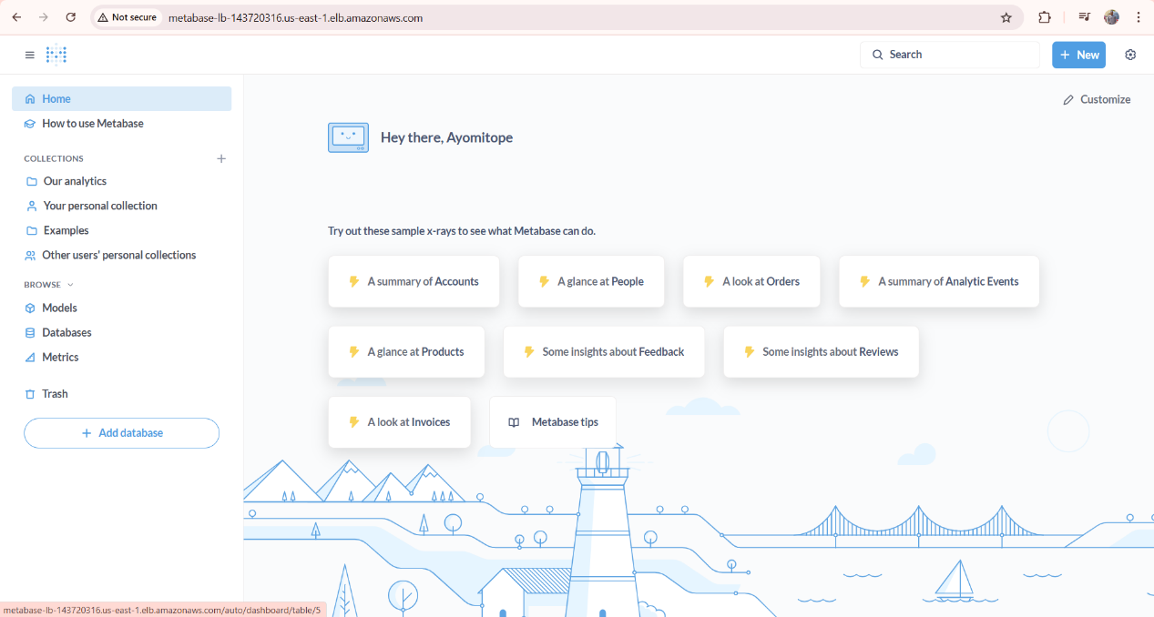

**WEEK 7**

**Create a Task Definition**

1. Go to **ECS > Task Definitions** > **Create new Task Definition**.
2. Choose **FARGATE**, click **Next**.
3. Configure:
   * Task Definition Name: grafana-tk
   * Task Role: *leave blank*
   * Network Mode: awsvpc
   * CPU & Memory: 1 vCPU/ **3 GB**

Under **Container definitions**, click **Add container**:  
Name: Grafana  
Image URI: grafana/grafana:latest  
Port mappings

Container port: 3000  
Protocol: tcp

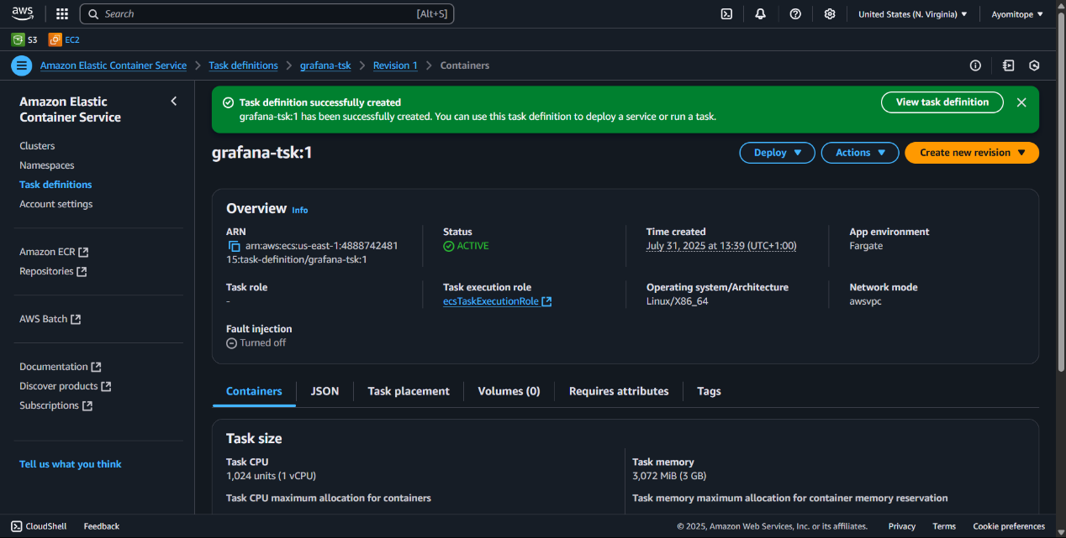

**Create an ECS Cluster**

* Go to **ECS > Clusters** > **Create Cluster**.
* Choose “Networking only (Fargate)” type.
* Named the cluster.

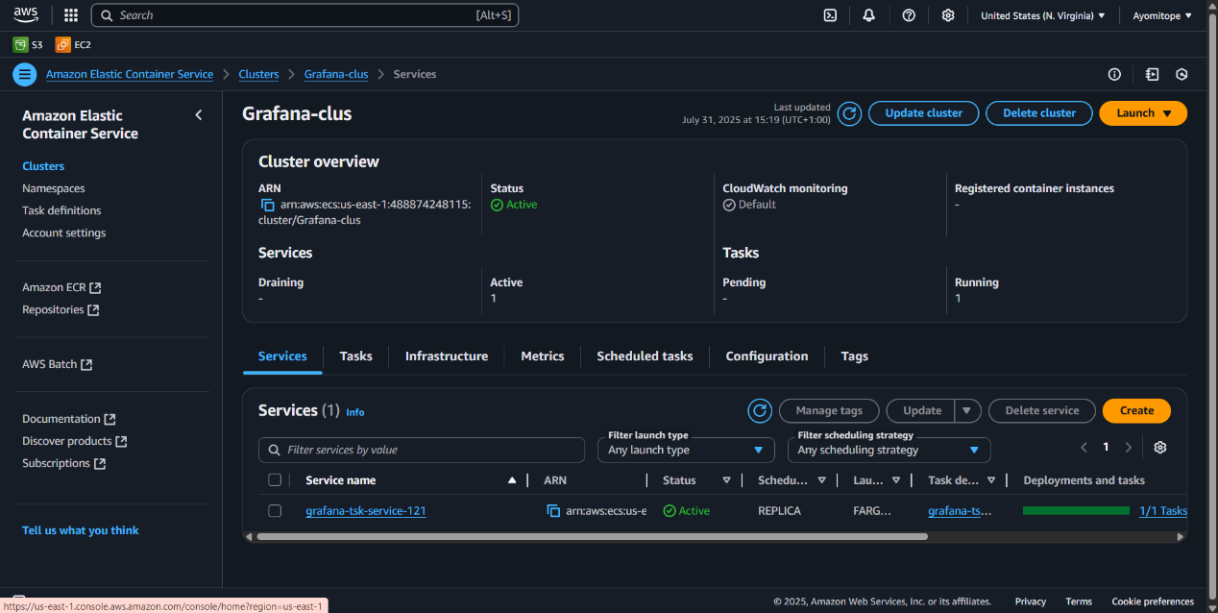

**Create a Service to Run the Task**

* In my cluster, create a **Service**:
* Launch type: Fargate.
* Task Definition: Select the one you created.
* Desired tasks: 1.
* Select VPC and public subnets.
* Enable **Auto-assign Public IP**

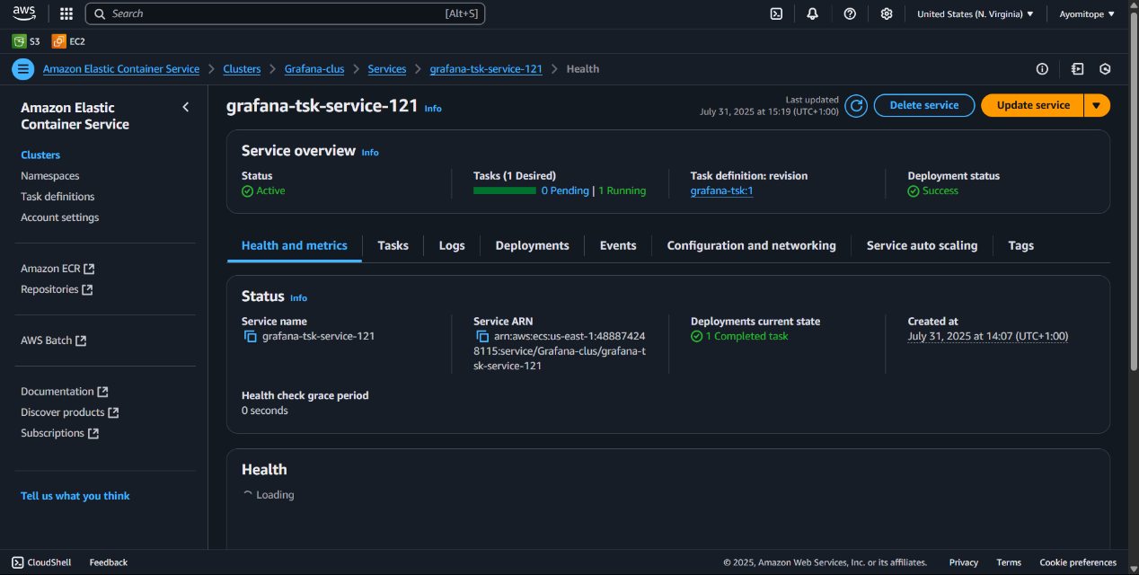

**Access Grafana**

1. In **ECS > Network Interfaces**, find the ENI attached to my Grafana task.
2. Copy its **Public IPv4 address**.( 3.81.11.155)
3. Open http:// 3.81.11.155:3000 in my browser.

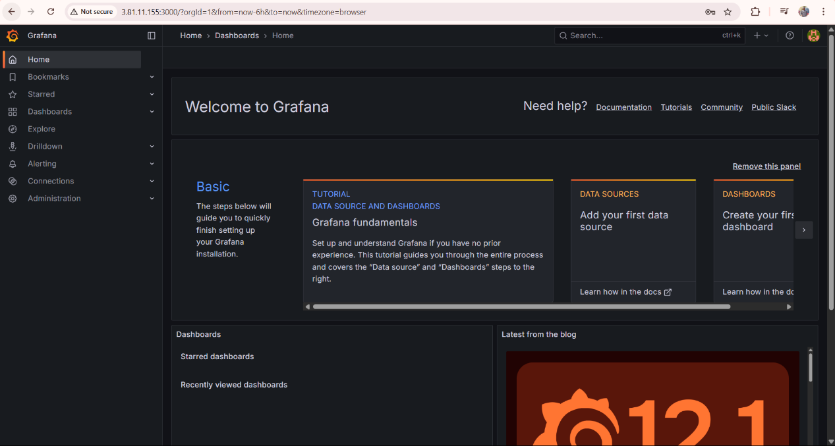

**Create CloudWatch Metrics Dashboard**

* Go to **CloudWatch > Dashboards** > **Create Dashboard**.
* Add 2 widgets:
* **Metric: ECS > Per-Task Metrics > CPUUtilization**
* **Metric: ECS > Per-Task Metrics > MemoryUtilization**

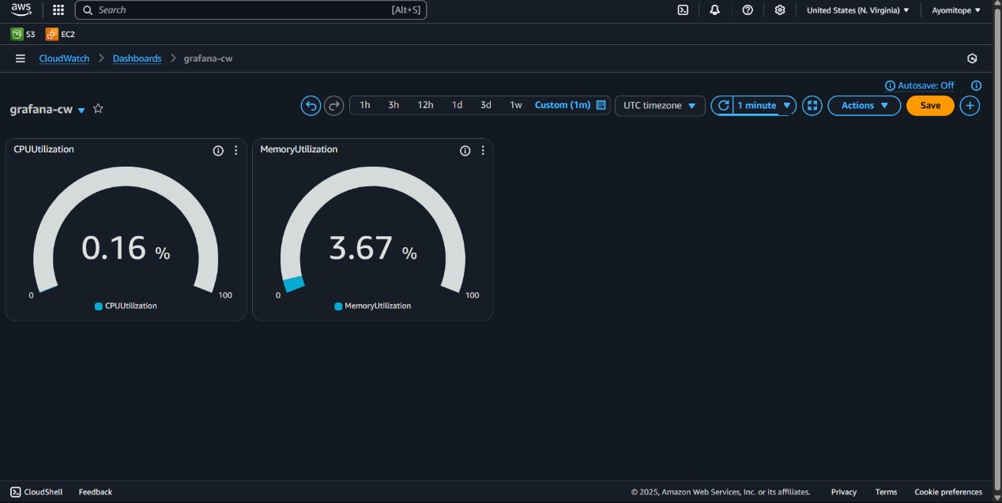

**Create an EC2 Instnace**

* Name: Grafana:csn
* **AMI**: Ubuntu Server 24.04 LTS (HVM), SSD Volume Type
* **Instance Type**: t2.micro & created networking settings(ticked HTTPS, SSH, HTTP)
* Launch Instance.

Connected to the instance through HTTPS

* Here are my commands for Ubuntu:  
  * sudo apt update  
  * sudo apt install apache2-utils -y  
  * ab -n 10000 -c 1000 http://3.81.11.155:3000/  
  *sudo apt install wrk -y  
  *wrk -t12 -c1000 -d30s http://3.81.11.155:3000  
  *wrk -t12 -c1000 -d60s http://3.81.11.155:3000

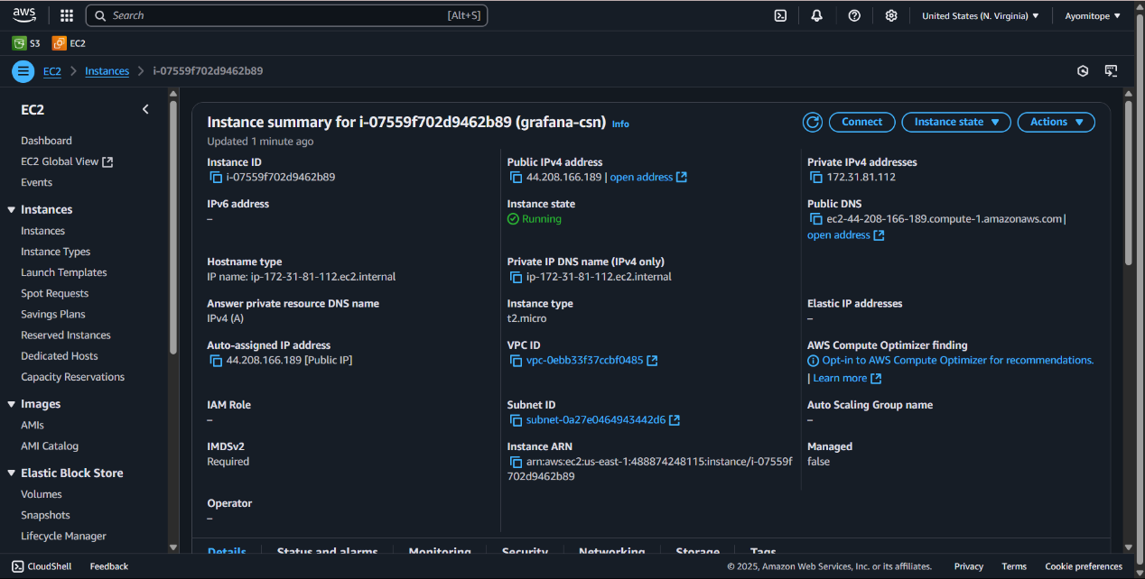

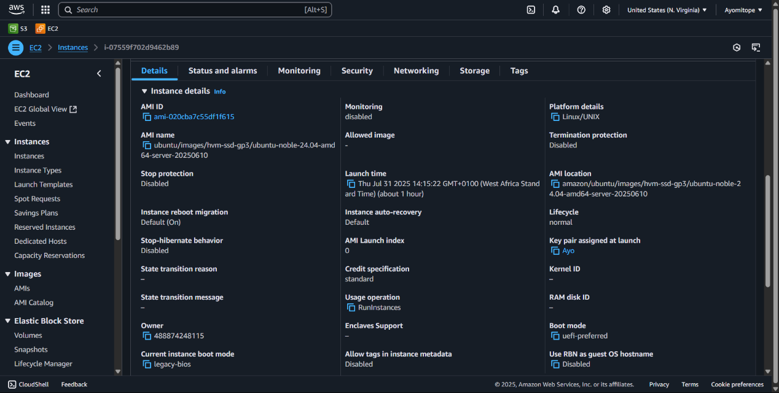  
  
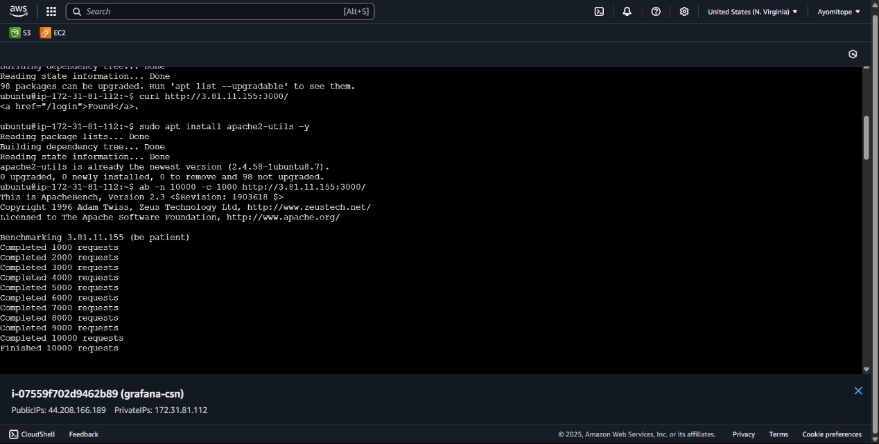

The change in the **CPUUtilization and MemoryUtilization**

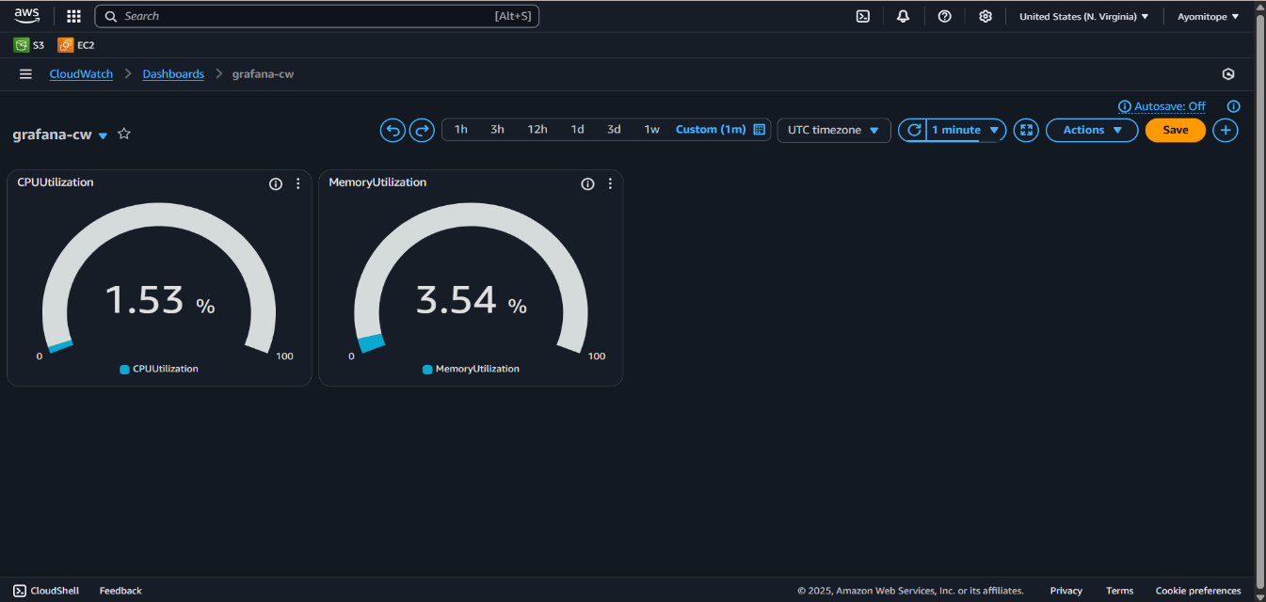

The changes in the **CPUUtilization and MemoryUtilization**

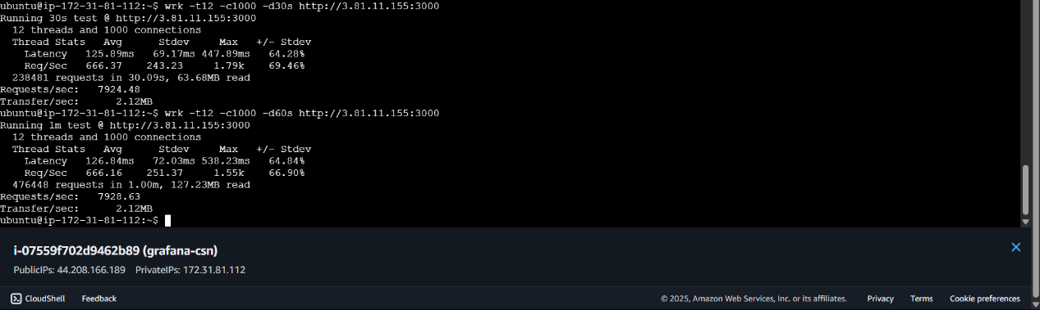

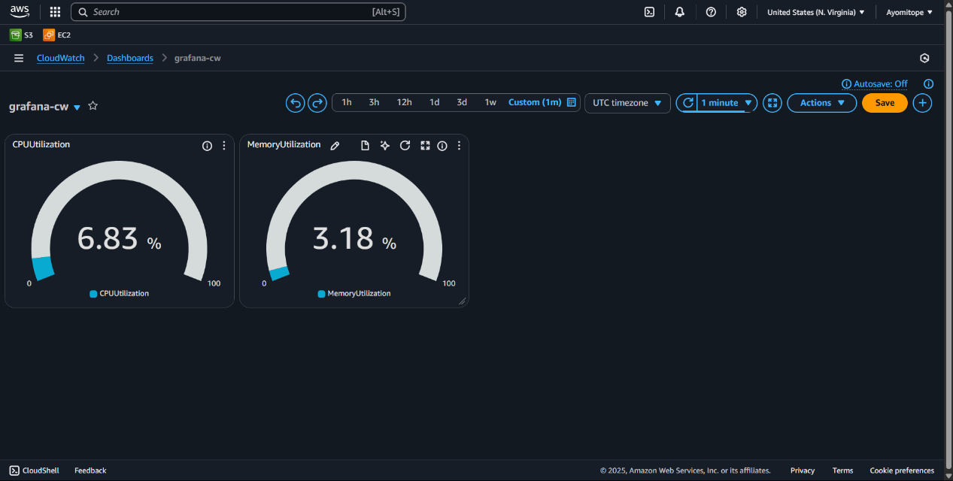

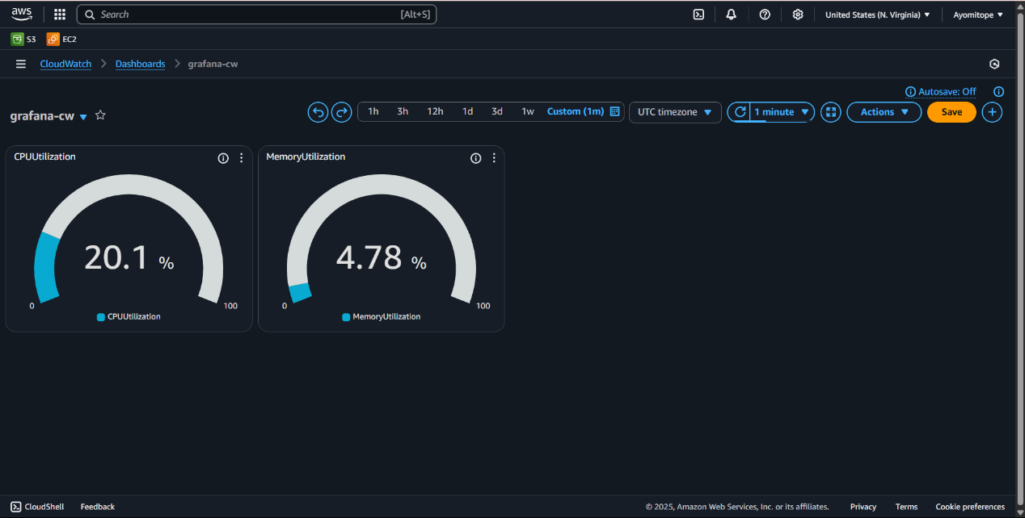

**WEEK 8**

**STEP 1:** Create an S3 Bucket  
**STEP 2:** Upload your HTML file  
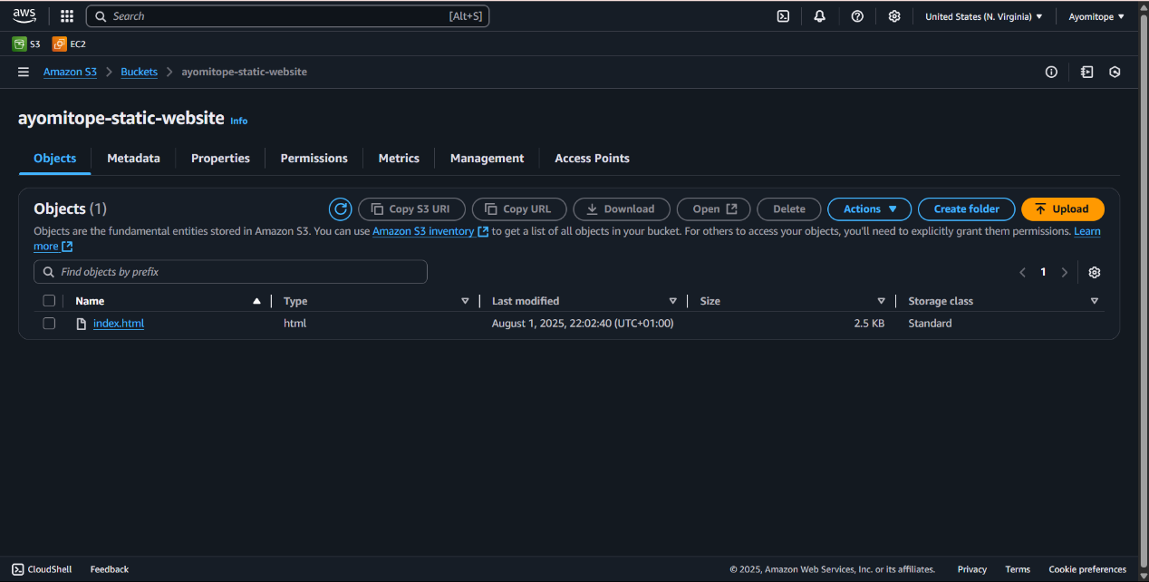  
**STEP 3:** Enable Static website  
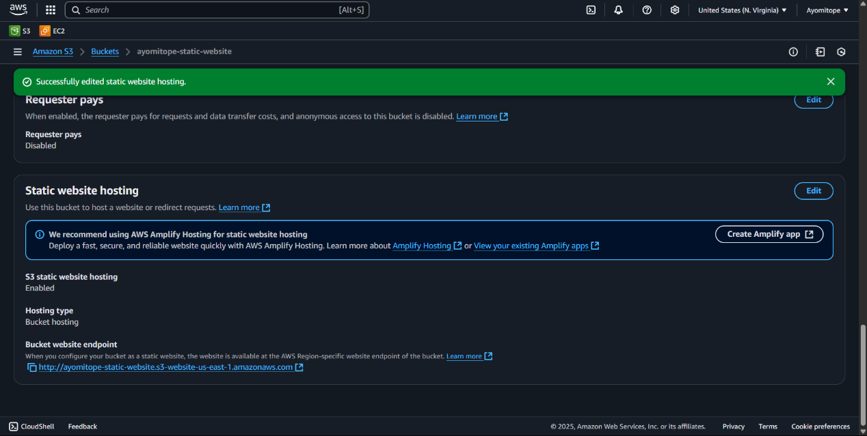  
  
**STEP 4**: Uncheck permission and edit the bucket policy  
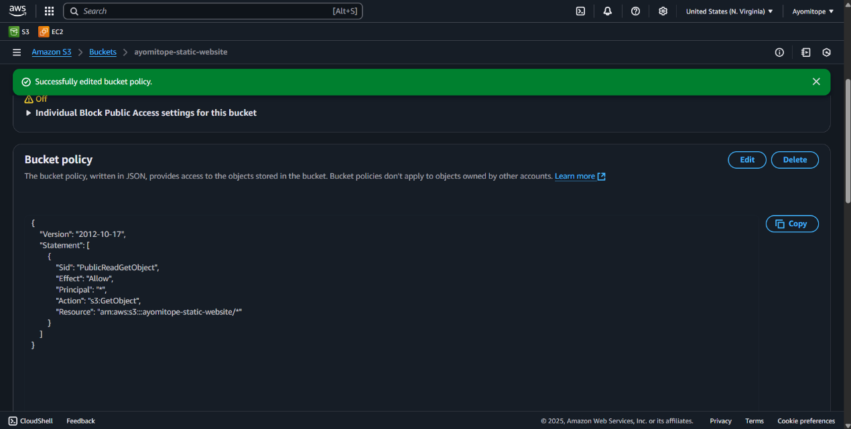  
  
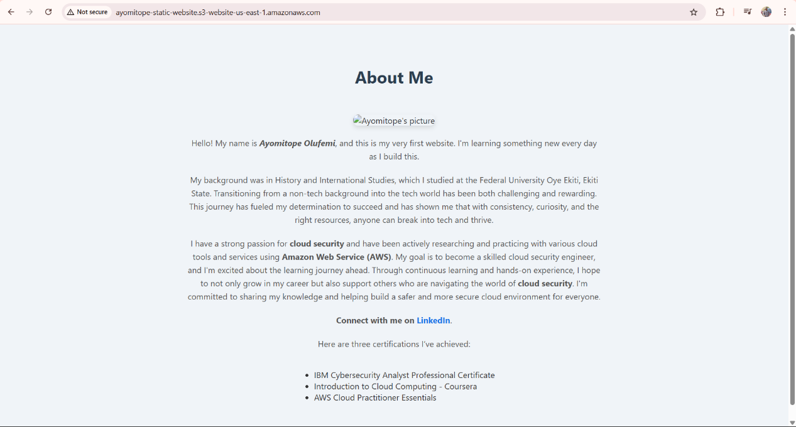  
**STEP 5:** Create a CloudFront Distribution to serve your site securely  
  
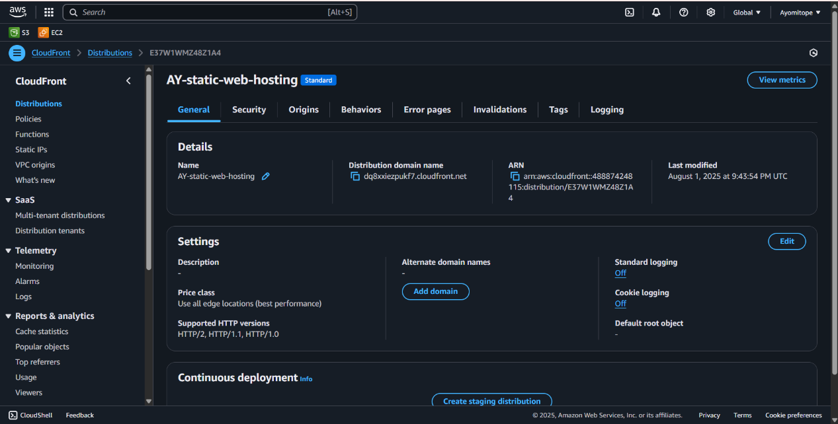  
  
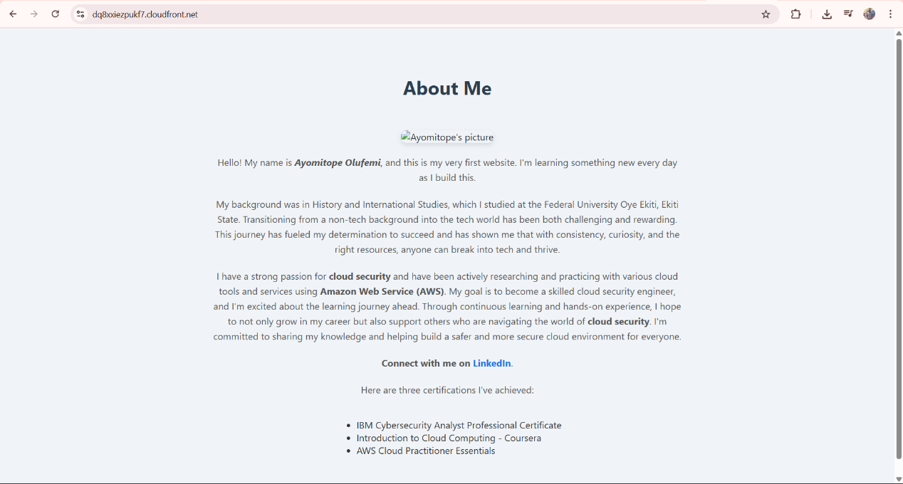

**WEEK 9**

**STEP 1: Set up my domain on deSEC (dedyn.io)**

* Created a **deSEC account** and registered the subdomain **ayoi.dedyn.io**.
* Managed all DNS records for this domain in deSEC (dedyn.io).

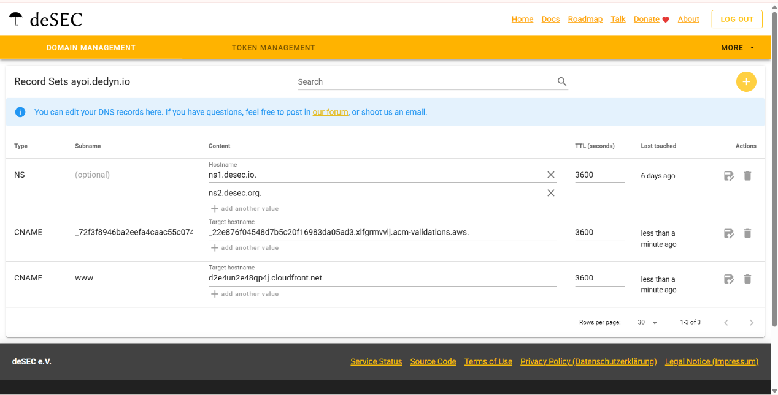

**STEP 2: Create the S3 Bucket for Website Hosting**

* In **S3 Console**, created a bucket named exactly as the domain: ayoi.dedyn.io.
* Disabled **Block Public Access** (if serving directly from S3).
* Uploaded the website files (index.html, style.css, etc.).
* Enabled **Static website hosting** in **Properties**, setting index.html as the root document.

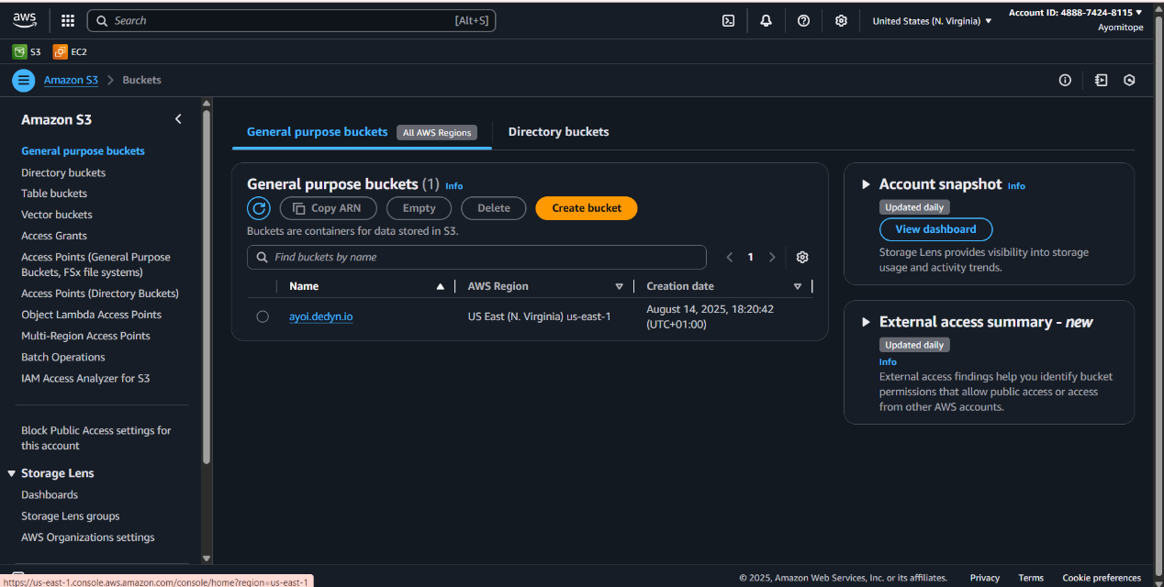

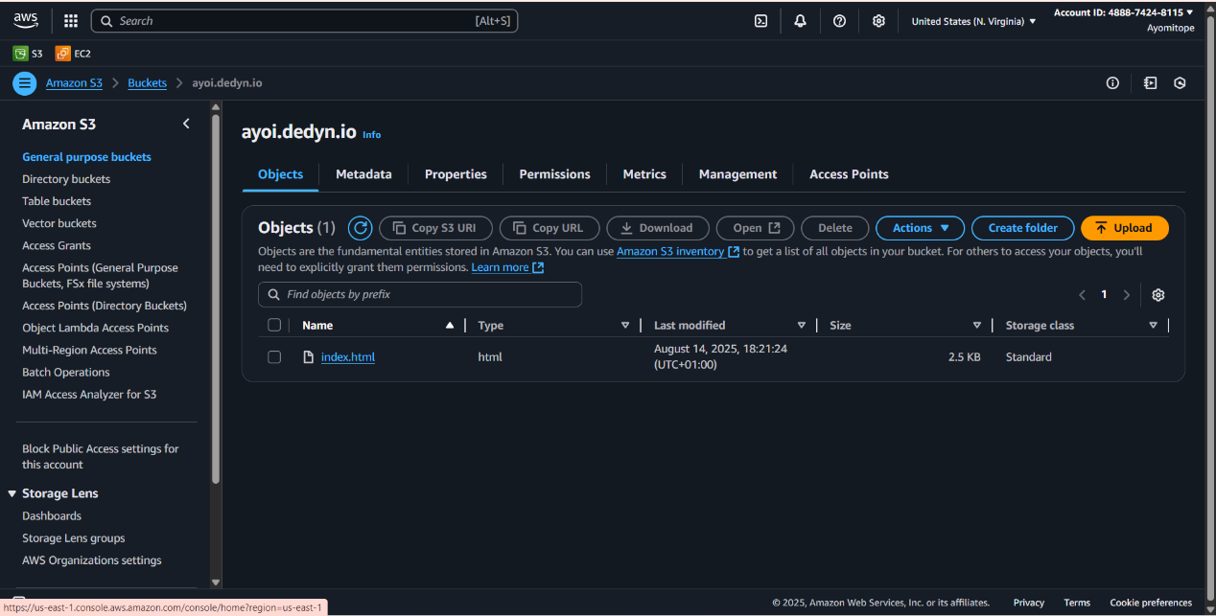

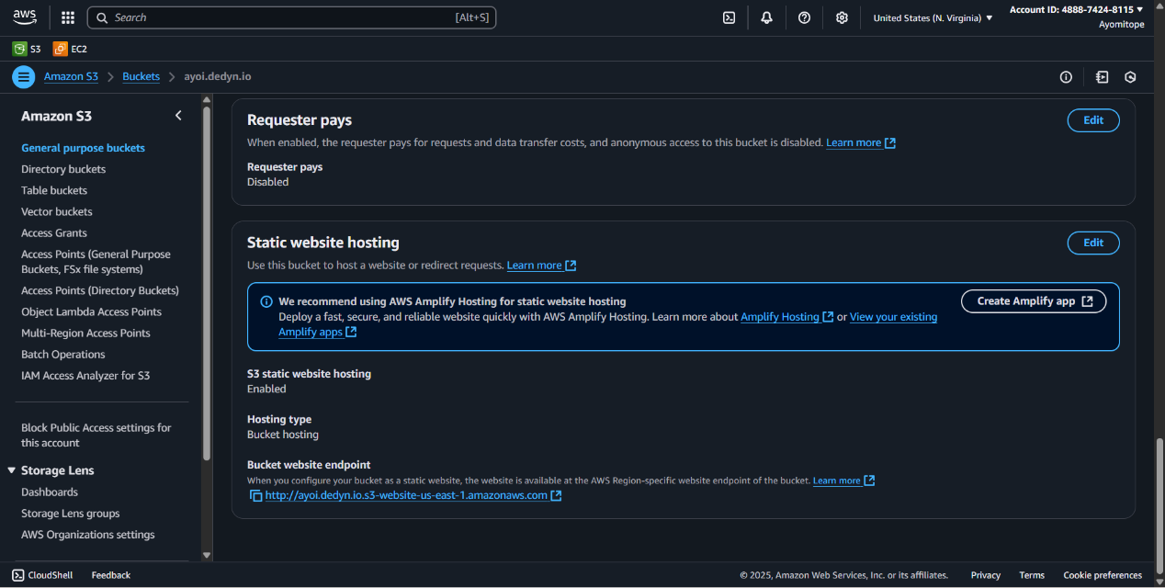

**STEP 3: Request an SSL/TLS Certificate in AWS Certificate Manager**

* Opened **AWS Certificate Manager (ACM)** in the **us-east-1** region (required for CloudFront).
* Requested a public certificate for:
  + *.ayoi.dedyn.io (wildcard for subdomains)
* Chose **DNS validation** and added the provided CNAME record in **Route 53**.
* Waited for the status to change to **Issued**.

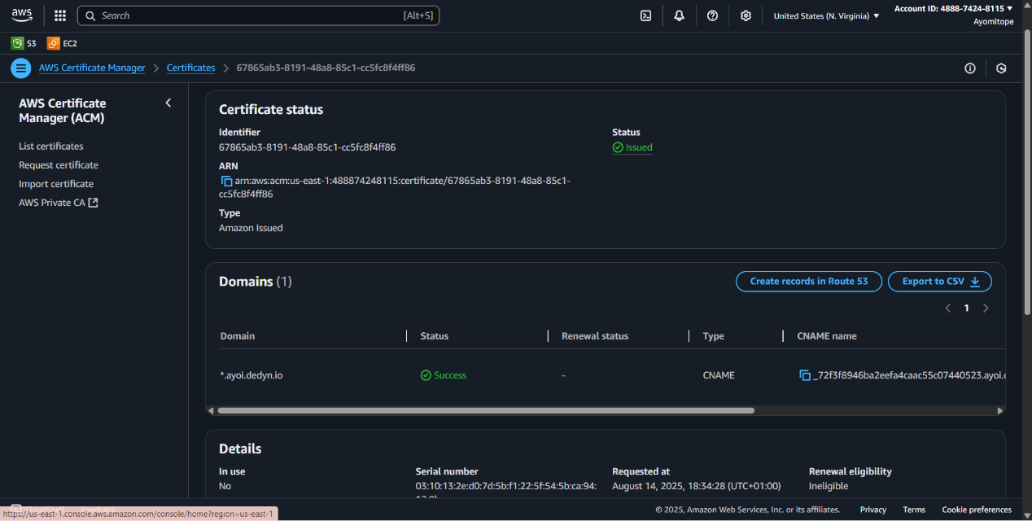

**STEP 4: Create a CloudFront Distribution**

* In **CloudFront Console**, created a new distribution.
* **Origin domain**: Selected the S3 bucket’s static website endpoint (or bucket name if using OAI/OAC for private content).
* **Viewer protocol policy**: Redirect HTTP to HTTPS.
* **Custom SSL certificate**: Selected the ACM certificate for *.ayoi.dedyn.io
* **Alternate domain names (CNAMEs)**: Added www.ayoi.dedyn.io
* Created the distribution and waited for deployment.

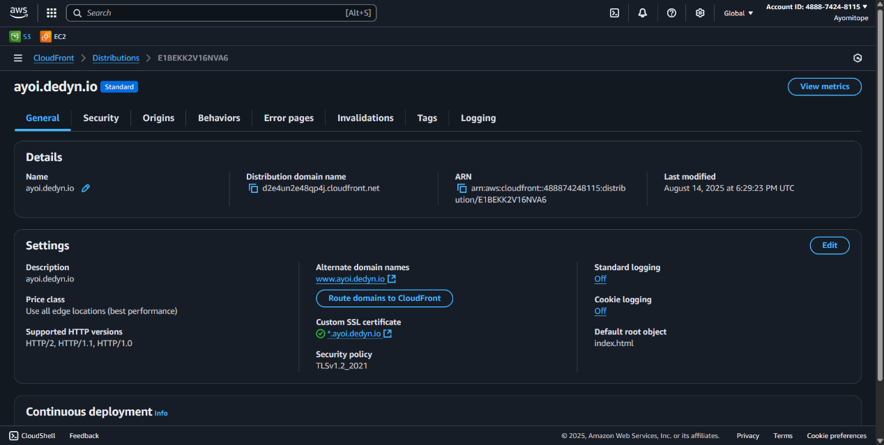

**STEP 5: Create a Route 53 Hosted Zone and DNS Records**

* In **Route 53**, created a hosted zone for dedyn.io if not already existing (or used existing if managed externally).
* Created an **A record (Alias)** pointing ayoi.dedyn.io to the CloudFront distribution.
* This ensures that when users type ayoi.dedyn.io, they are routed through CloudFront to the S3 bucket.

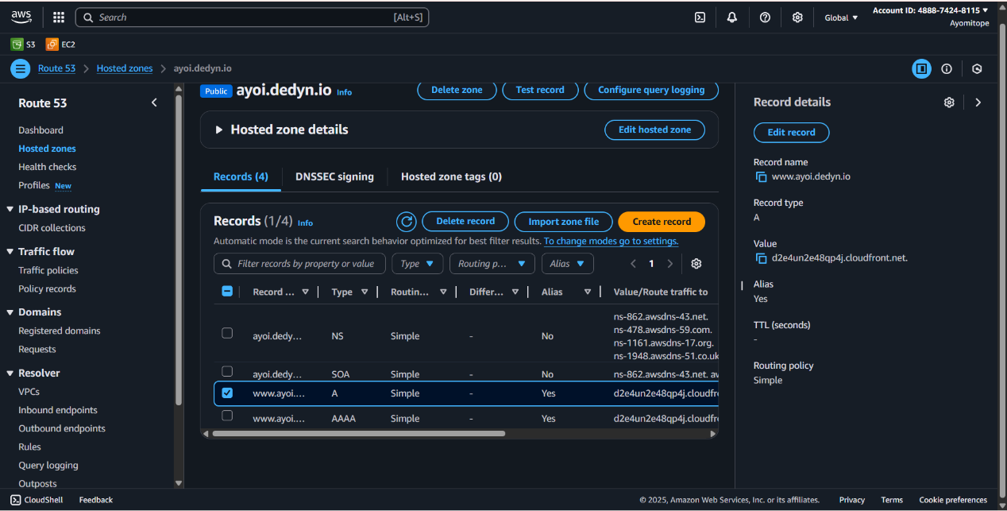

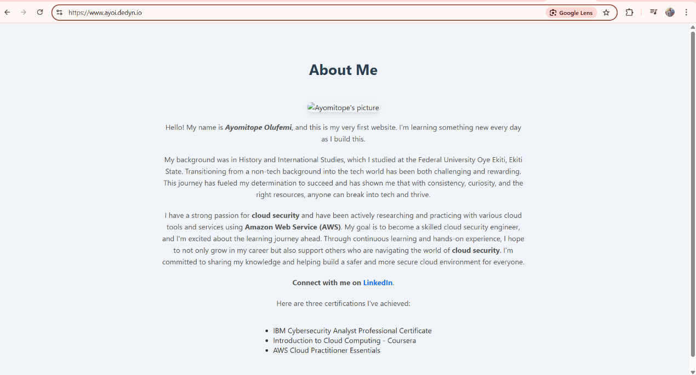

**WEEK 10**   
**Step 1:** Create an S3 Bucket  
Go to the AWS Management Console and open the Amazon S3 service  
Click "Create bucket"  
Name: ayomi-upload-trigger  
Choose your preferred AWS Region  
Keep all other settings as default and click "Create bucket"

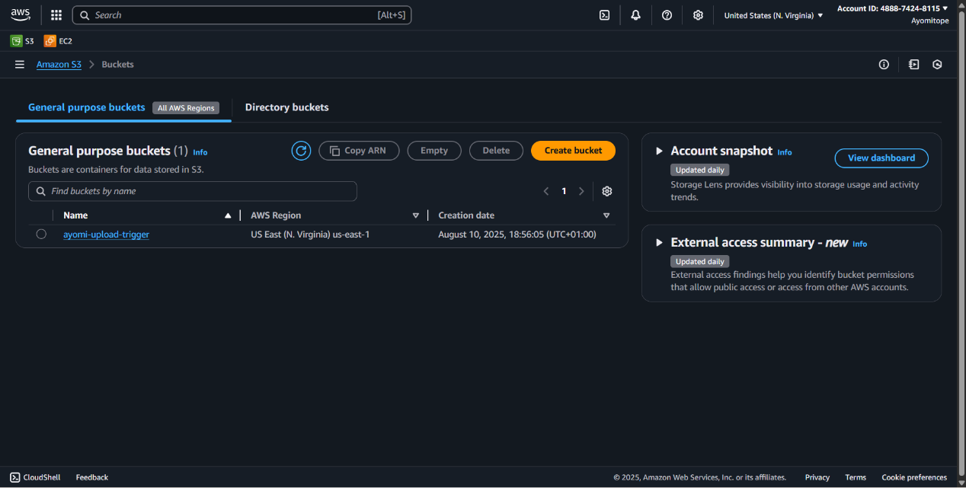  
  
**Step 2:** Create an IAM Role for Lambda  
Click "Roles" then "Create role"  
Select "AWS service" as trusted entity type  
Choose "Lambda" as the use case  
Click "Next"  
Attach the following policies:  
AWSLambdaBasicExecutionRole (for CloudWatch logging)  
AmazonS3ReadOnlyAccess (to read S3 event data)  
AmazonSESFullAccess (SES for email notifications)  
Click "Next"  
Name the role: lambda-trigger-role-csn

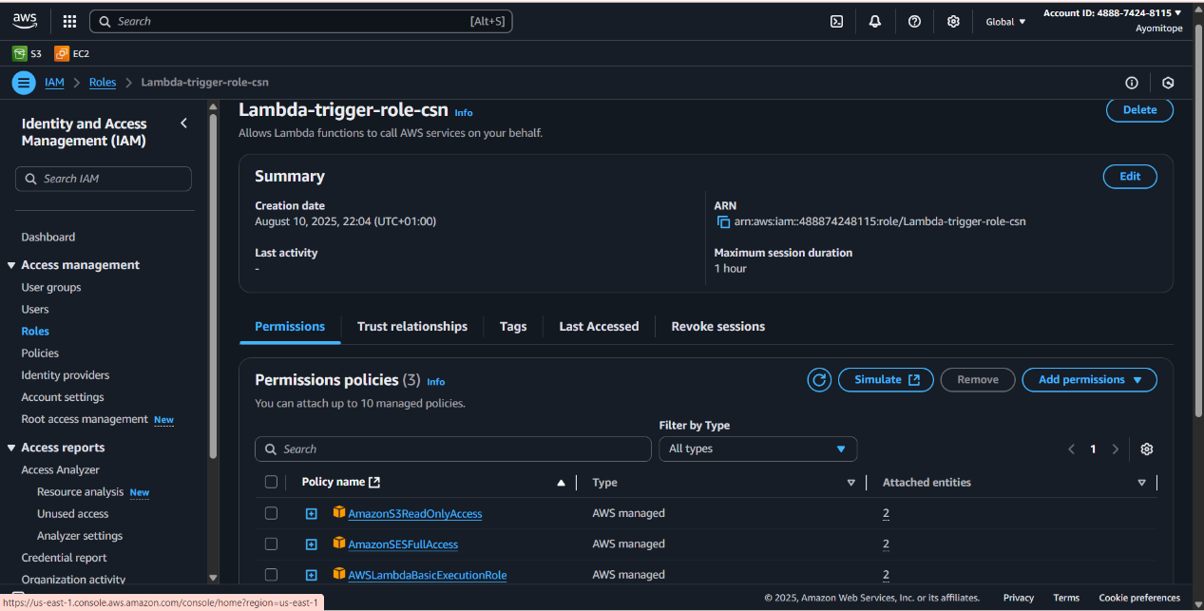  
  
**Step 3**: Verify SES Email Addresses  
Go to the Amazon SES service  
Click "Verified identities" in the left menu  
Click "Create identity"  
Choose "Email address" and enter your sender email  
Click "Create identity"  
Check your email inbox for a verification email and click the link

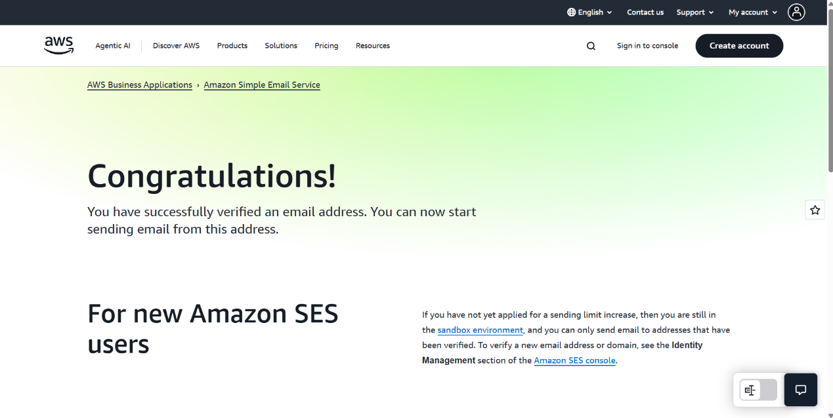

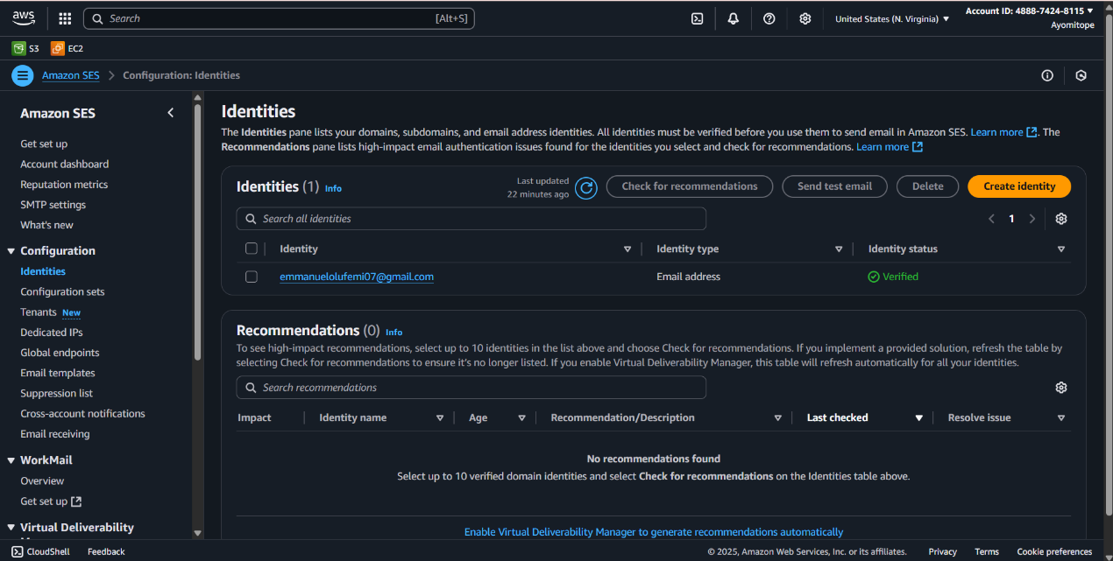

**Step 4:** Create the Lambda Function  
Go to the AWS Lambda service  
Click "Create function"  
Choose "Author from scratch"  
Enter a function name (e.g., "s3-upload-notifier")  
Select Python 3.13 as runtime  
Under "Permissions", choose "lambda-trigger-role-csn" and select the role you created  
Click "Create function"

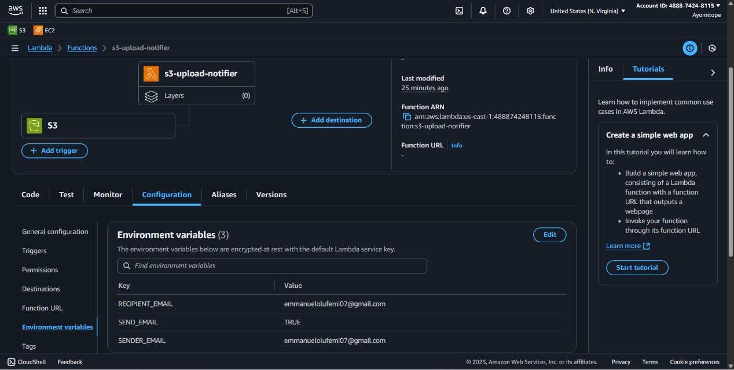  
  
**Step 5**: Write the Lambda Function Code  
Here's a Python Lambda function that logs the file name and sends an email:  
  
import boto3

import os

import logging

logger = logging.getLogger()

logger.setLevel(logging.INFO)

def lambda_handler(event, context):

for record in event['Records']:

bucket = record['s3']['bucket']['name']

key = record['s3']['object']['key']

logger.info(f"New file uploaded: {key} to bucket: {bucket}")

if os.environ.get('SEND_EMAIL', 'false').lower() == 'true':

send_email(bucket, key)

return {

'statusCode': 200,

'body': f"Processed upload of {key}"

}

def send_email(bucket, key):

ses = boto3.client('ses')

sender = os.environ['SENDER_EMAIL']

recipient = os.environ['RECIPIENT_EMAIL']

subject = f"New file uploaded: {key}"

body = f"Bucket: {bucket}\nFile: {key}"

ses.send_email(

Source=sender,

Destination={'ToAddresses': [recipient]},

Message={

'Subject': {'Data': subject},

'Body': {'Text': {'Data': body}}

}

) 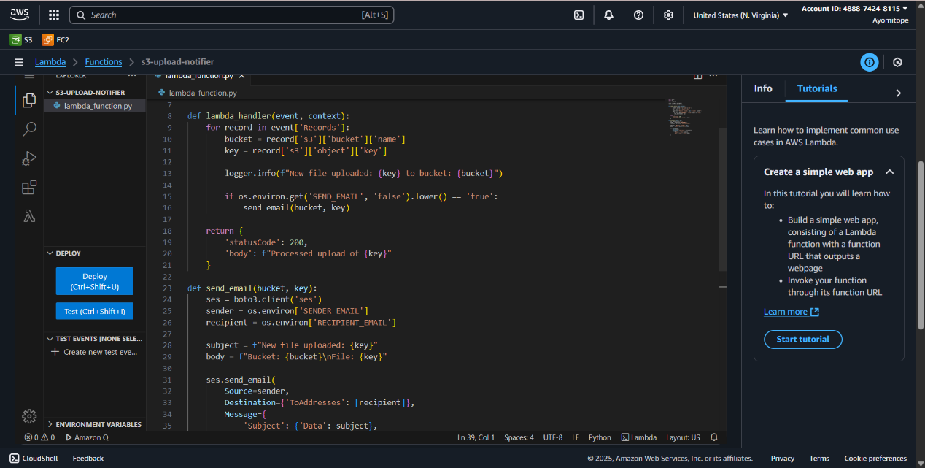

**Step 6:** Configure Lambda Environment Variables  
In your Lambda function, go to the "Configuration" tab  
Click "Environment variables"  
Add the following variables:  
SENDER_EMAIL - Your verified SES sender email  
RECIPIENT_EMAIL - The email address to receive notifications  
SEND_EMAIL - Set to "true" to enable email notifications  


**Step 7:** Set Up S3 Trigger  
In your Lambda function, go to the "Configuration" tab  
Click "Add trigger"  
Select "S3" as the trigger type  
Choose your bucket from the dropdown  
For "Event type", select "All object create events"  
Optionally add a prefix/suffix filter if needed  
Check "Recursive invocation" if you want subfolder events  
Click "Add"  
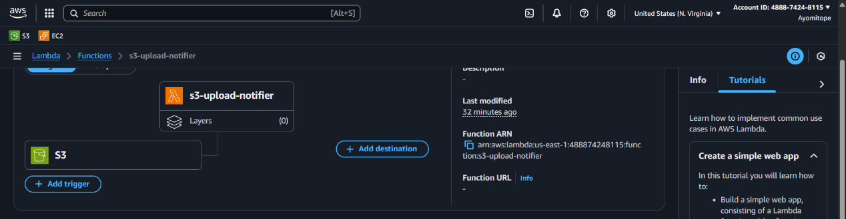  
  
**Step 8:** Test the Setup  
Upload files to your S3 bucket  
I uploaded two files in my S3 buckets and checked the log from my CloudWatch and an email from AWS concerning the new files uploaded.

